登高展望 | 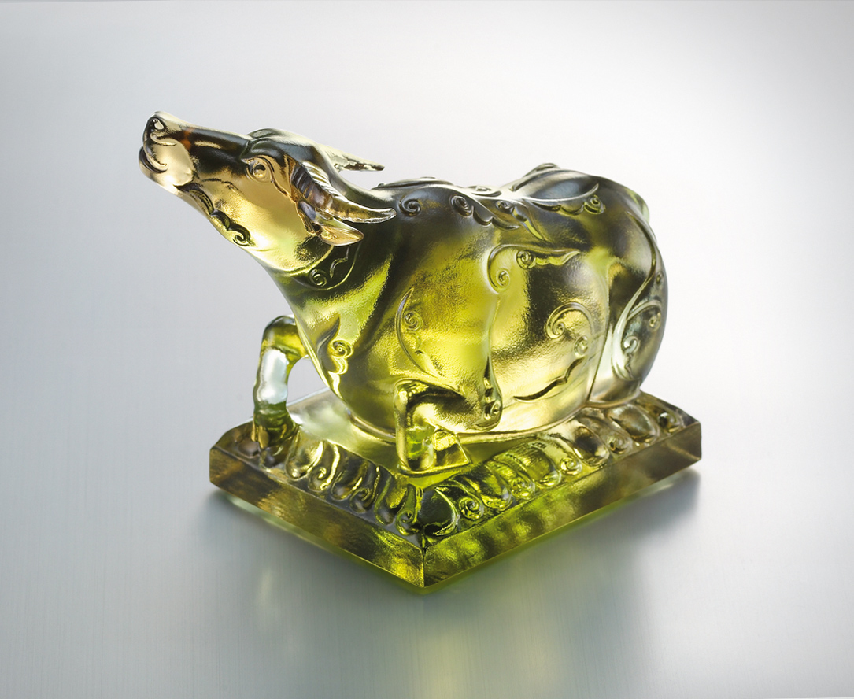
藉此登高
坐看雲起的創意
掌握風的速度 光的氣度
再飲水思源 蓄勢熱情
向未來
Go High Go Distant
Up there firmly sat Enjoy the clouds overhead Have you had the wind in palm, let light shone bright and calm Bowing for a sip, from where the fountain drips Gear up, the future a distant trip

編號 | 1552694 | No | 1552694
名稱 | 登高展望 | Name | Go High Go Distant
顏色 | 茶綠透 | Color
尺寸 | 7.1 * 11.7 * 9.2 | Size | 7.1 * 11.7 * 9.2
重量 | 0.77 | Weight | 0.77
限量 | X | Limited Edition | X
售價 | NT$ 5280 | Price | NT$ 5280
 | RMB$ 1320 |  | RMB$ 1320

