富足圓滿 | 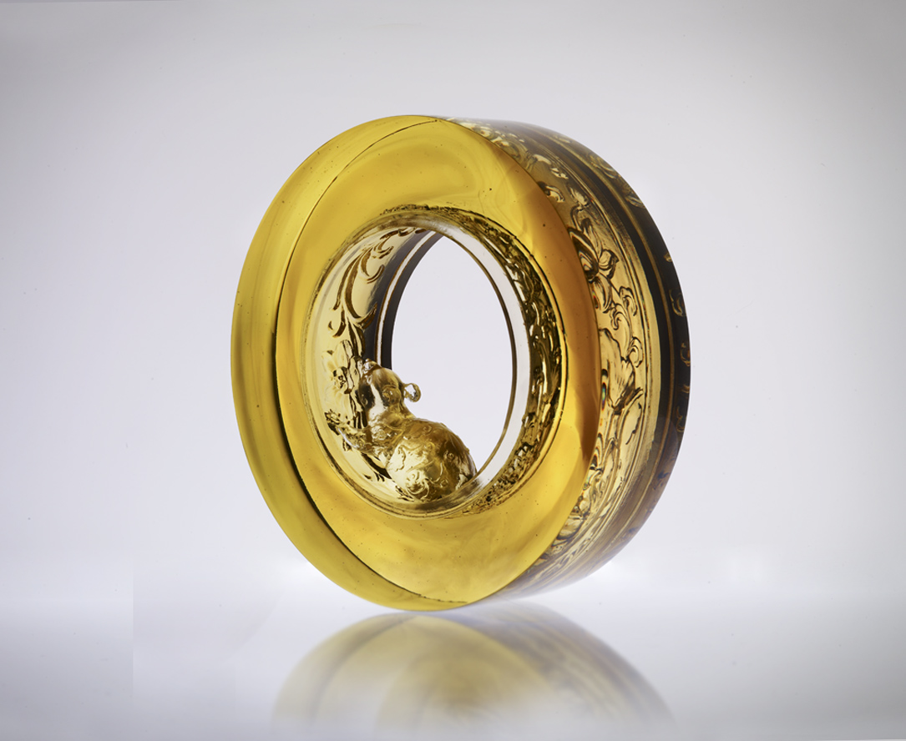
細細咀嚼
每一方寸的華麗情義
真心誠意
匯聚圓圓滿滿福報
步步探尋
每一節氣的芳香富足
日積月累
豐享源源滾滾榮景
Plentiful Prosperity and Perfection
Masticate exquisitely Every inch in gorgeous sentiment Sincerity and heartfelt Are gathered into good fortunes With every single step explored Accumulates to Great prosperity and continuous wealth

編號 | 1552614 | No | 1552614
名稱 | 富足圓滿 | Name | Plentiful Prosperity and Perfection
顏色 | 茶金 | Color
尺寸 | 5.5 * 16.9 * 16.9 | Size | 5.5 * 16.9 * 16.9
重量 | 2.88 | Weight | 2.88
限量 | O | Limited Edition | O
售價 | NT$ 19800 | Price | NT$ 19800
 | RMB$ 4966 |  | RMB$ 4966

