如意結果 | 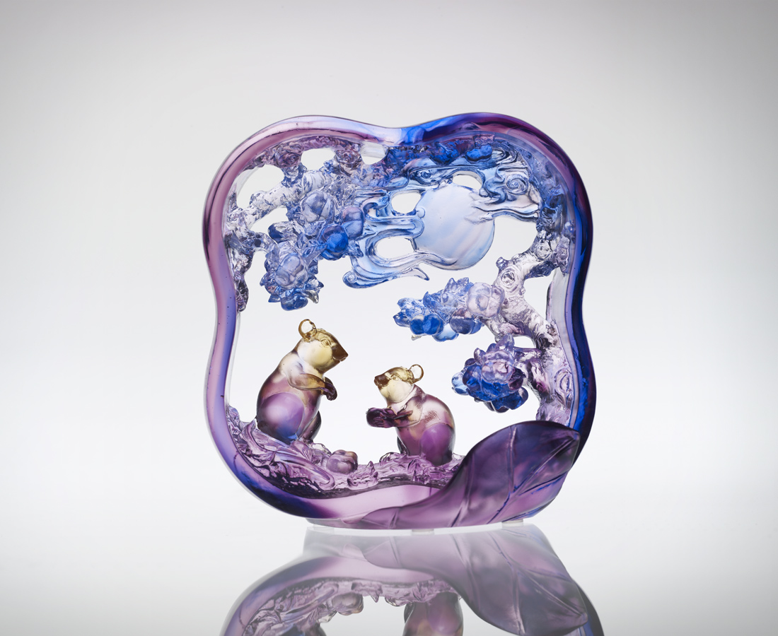
頂著耀日月的信心
繞著風雲起的夢想
說好 樂觀進取
講妥 熱情鼓舞
盡管 力耕勤耘
始終 合作無間
自然柿柿如意
四方繽紛結果
Outcomes of Desire
With confidence sky-high Dreams winding the clouds Agreed to optimistic paths Settled on passionate dances Fully throttled on diligence Always collaborative harmony Then means naturally follow Toward a victorious outcome

編號 | 1552536 | No | 1552536
名稱 | 如意結果 | Name | Outcomes of Desire
顏色 | 粉琥紫藍 | Color
尺寸 | 5.3 * 12.5 * 12.8 | Size | 5.3 * 12.5 * 12.8
重量 | 0.58 | Weight | 0.58
限量 | X | Limited Edition | X
售價 | NT$ 7960 | Price | NT$ 7960
 | RMB$ 1988 |  | RMB$ 1988

