藏富 | 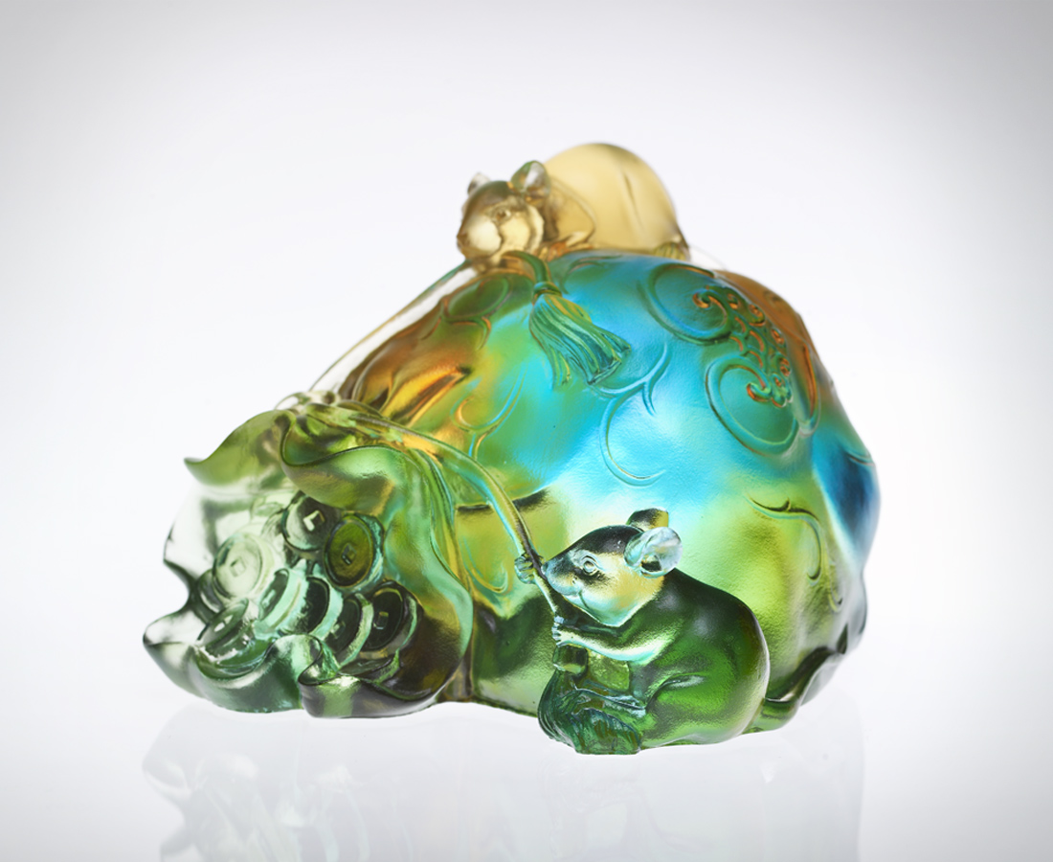
胼手胝足
攢滿智慧經驗
點點滴滴
儲滿人氣資糧
數不盡的情義相助
說不完的冒險犯難
樂在工作 樂於分享
永保富貴人生
Hidden Treasure
Enriching knowledge Accumulated with work Bit by bit Stashing life nourishments Endless passionate aids Countless adventurous risks Joyful working and sharing For eternal riches in life

編號 | 1552518 | No | 1552518
名稱 | 藏富 | Name | Hidden Treasure
顏色 | 琥綠青 | Color
尺寸 | 10.7 * 12.3 * 8.2 | Size | 10.7 * 12.3 * 8.2
重量 | 1.0 | Weight | 1.0
限量 | X | Limited Edition | X
售價 | NT$ 6260 | Price | NT$ 6260
 | RMB$ 1566 |  | RMB$ 1566

