齊飛圓夢 | 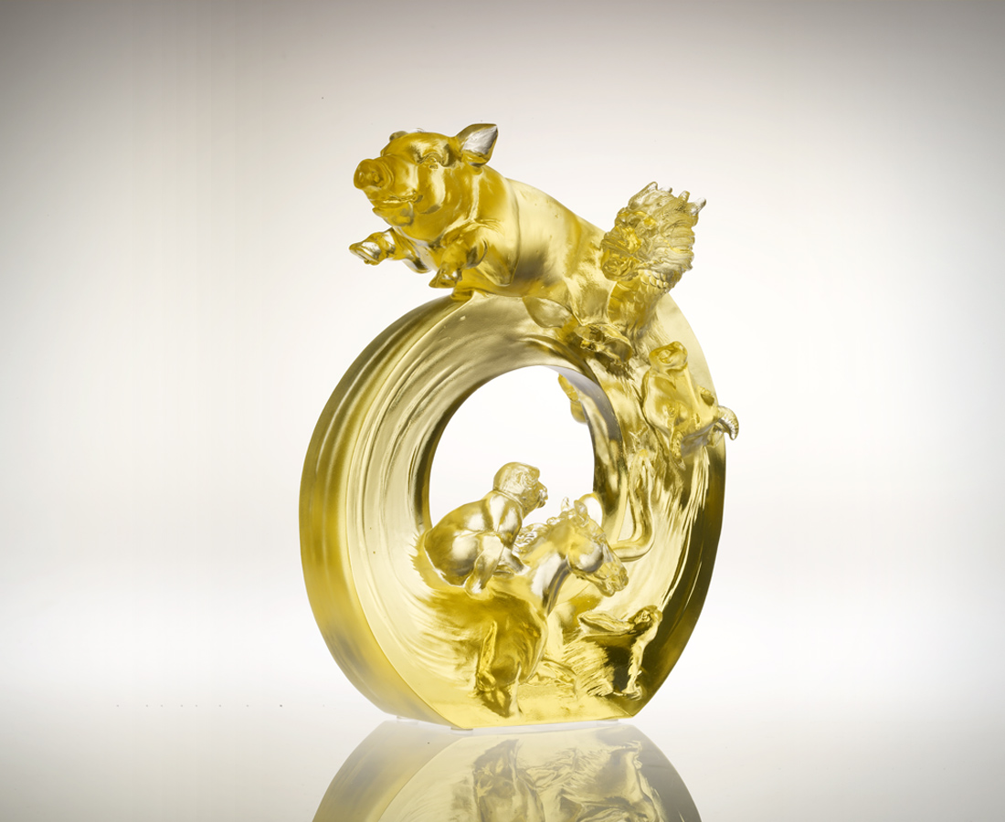
快樂不是夢想
成功不是奢望
與人分享 多歡喜
與人合力 早如願
放足而奔 信心飛揚
有你有我有他
夢成真
Realization of Dreams
Happiness is no longer just a dream Success is no longer an unattainable desire Share with others, and more delight will descend upon you Collaborate with others, path to triumph will be abbreviated Roam free, let your spirit soar with confidence Together, we can make our dreams come true

編號 | 1552483 | No | 1552483
名稱 | 齊飛圓夢 | Name | Realization of Dreams
顏色 | 金 | Color
尺寸 | 7.3 * 14.8 * 19.2 | Size | 7.3 * 14.8 * 19.2
重量 | 2.0 | Weight | 2.0
限量 | O | Limited Edition | O
售價 | NT$ 13860 | Price | NT$ 13860
 | RMB$ 3466 |  | RMB$ 3466

