樂天常富 | 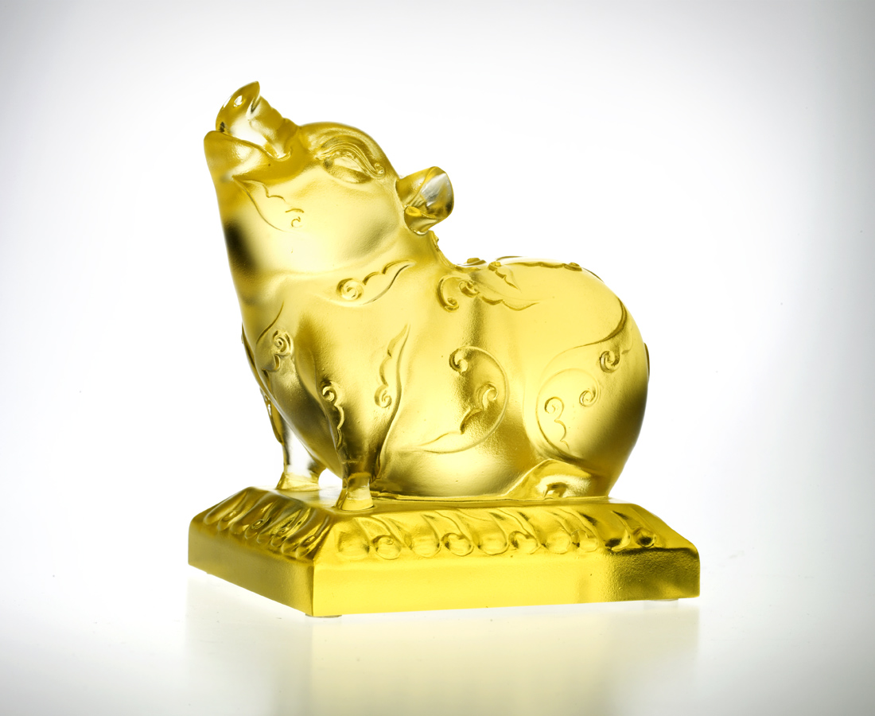
仰天常笑
如意會紋身
頭抬高 看得遠
身蹲低 走得穩
笑得開 氣長足
一生富足樂陶然
Content with Happiness
With head tilted skywards Smiling Good luck and fortune May yet be forthcoming Standing tall to see big picture Staying low to walk firm Always laughing, always energetic, Life is filled with contents and happiness

編號 | 1552414 | No | 1552414
名稱 | 樂天常富 | Name | Content with Happiness
顏色 | 綠藍琥透 / 紅透(難製) / 金 / | Color
尺寸 | 6.8 * 9.8 * 10.4 | Size | 6.8 * 9.8 * 10.4
重量 | 0.9 | Weight | 0.9
限量 | X | Limited Edition | X
售價 | NT$ 5260 | Price | NT$ 5260
 | RMB$ 1322 |  | RMB$ 1322

