望旺得勝 | 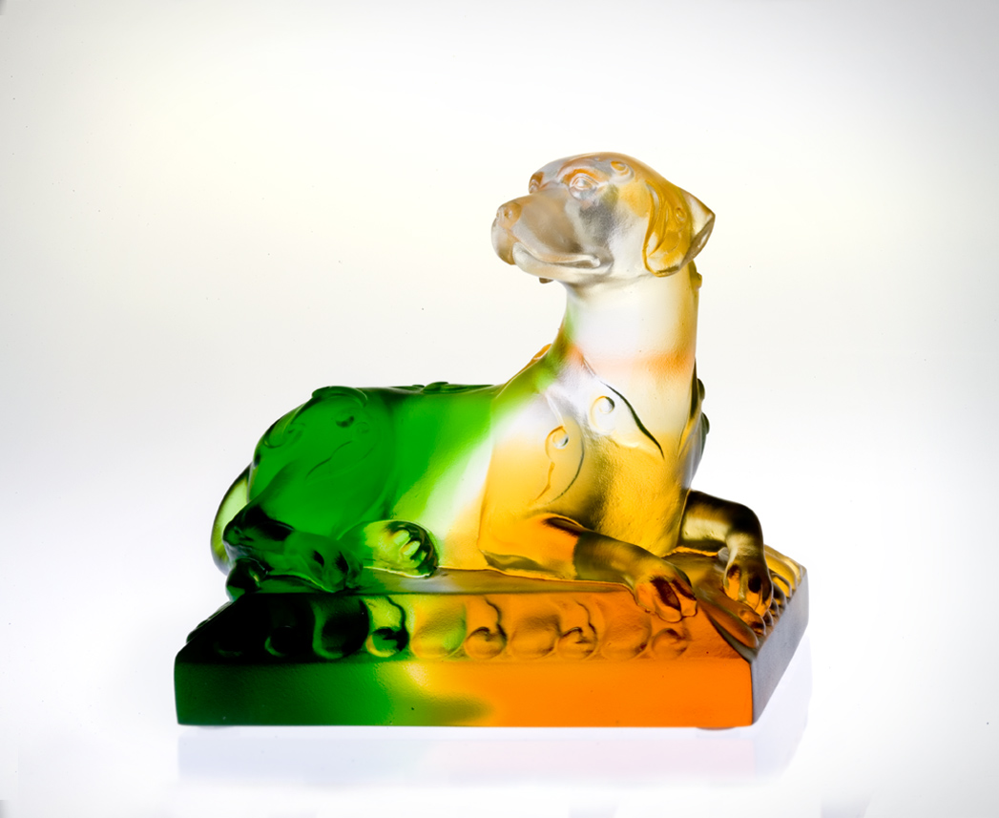
旺旺 一鼓作氣
吠出 無限振奮
望望 起身遠眺
看出 潮流時勢
自信無懼 勇往直前
警覺敏銳 對應及時
有眼光 有決心
望旺得勝
Hooray to Victory
Huff – in one deep breath, and Puff – in one thunderous release. Look – beyond the surrounding, and Gaze – into the torrent current. Confident and fearless, Charge forward with all your might. Alert and perceptive, Let your instinct guide your determination To the victorious destination.

編號 | 1552371 | No | 1552371
名稱 | 望旺得勝 | Name | Hooray to Victory
顏色 | 琥綠透 | Color
尺寸 | 6.8 * 9 * 8.1 | Size | 6.8 * 9 * 8.1
重量 | 0.46 | Weight | 0.46
限量 | X | Limited Edition | X
售價 | NT$ 5280 | Price | NT$ 5280
 | RMB$ 1322 |  | RMB$ 1322

