忠愛一生 | 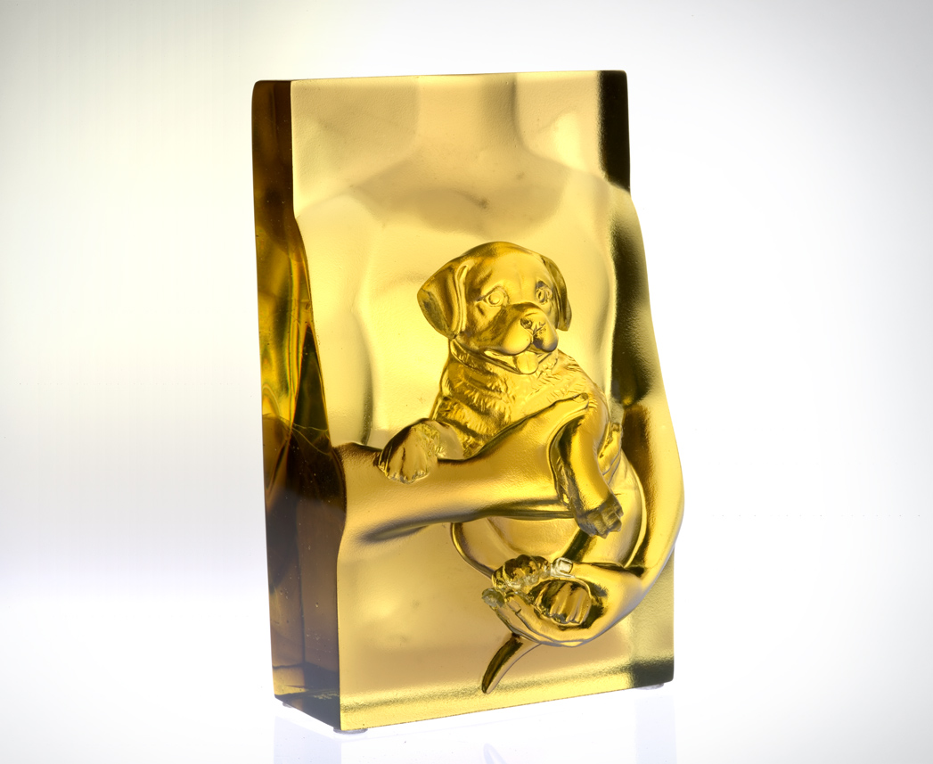
交出無私的忠誠
接住無盡的關愛
緊貼坦蕩的心胸
懷抱開闊的信任
一呼一吸 共振默契
一言一笑 共鳴歡喜
愛的交融 渾然天成
沒有重量
Loving for Life
Giving in sincerity and without restraint Receiving endless love and concern Embracing honesty with a passion Enveloped by trust and magnanimity Breathing and living in unity Speaking and laughing as one The natural bond of true love Is immeasurable

編號 | 1552358 | No | 1552358
名稱 | 忠愛一生 | Name | Loving for Life
顏色 | 茶金 | Color
尺寸 | 7.2 * 8.3 * 13.5 | Size | 7.2 * 8.3 * 13.5
重量 | 1.23 | Weight | 1.23
限量 | X | Limited Edition | X
售價 | NT$ 6280 | Price | NT$ 6280
 | RMB$ 1566 |  | RMB$ 1566

