穩坐寶山 | 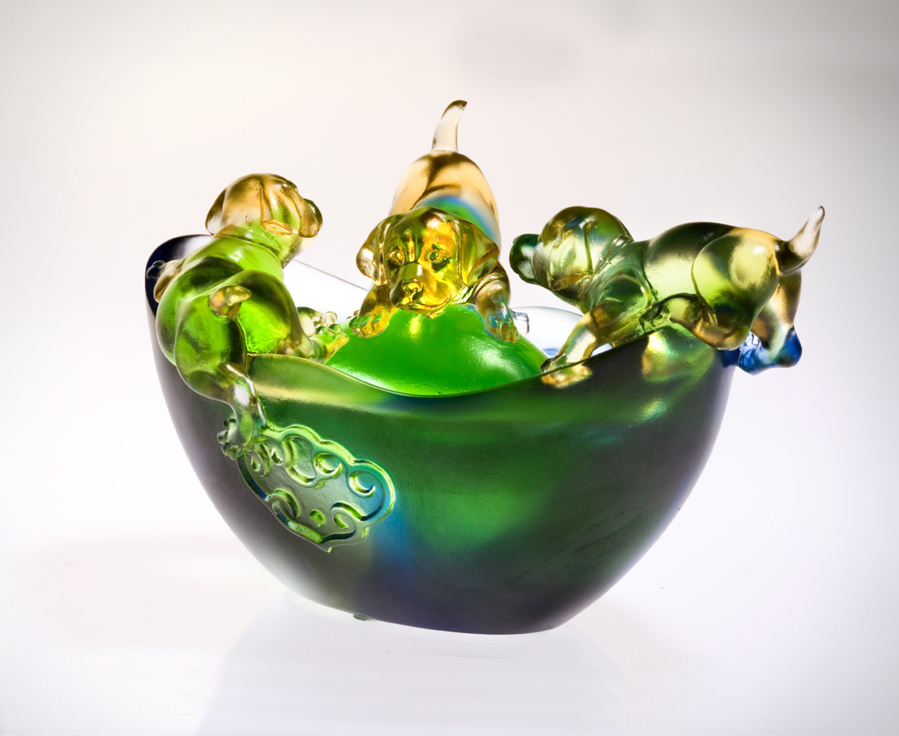
無論輸贏 必須一探
伸出拳腳 只管嘗試
盡心盡力 認真付出
渾身解數 鍛鍊身心
一生 與人為善
一世 穩坐寶山
The Seat of Power
Explore without fear of loss; Aspire to seek the for sake of trying. Give all that your body and heart can And success always in the trials of endurance. Extend good will throughout the days Enjoy power in security throughout your life.

編號 | 1552321 | No | 1552321
名稱 | 穩坐寶山 | Name | The Seat of Power
顏色 | 琥綠青透 | Color
尺寸 | 8.7 * 13.3 * 8.5 | Size | 8.7 * 13.3 * 8.5
重量 | 0.7 | Weight | 0.7
限量 | X | Limited Edition | X
售價 | NT$ 5980 | Price | NT$ 5980
 | RMB$ 1488 |  | RMB$ 1488

