開懷昌旺 | 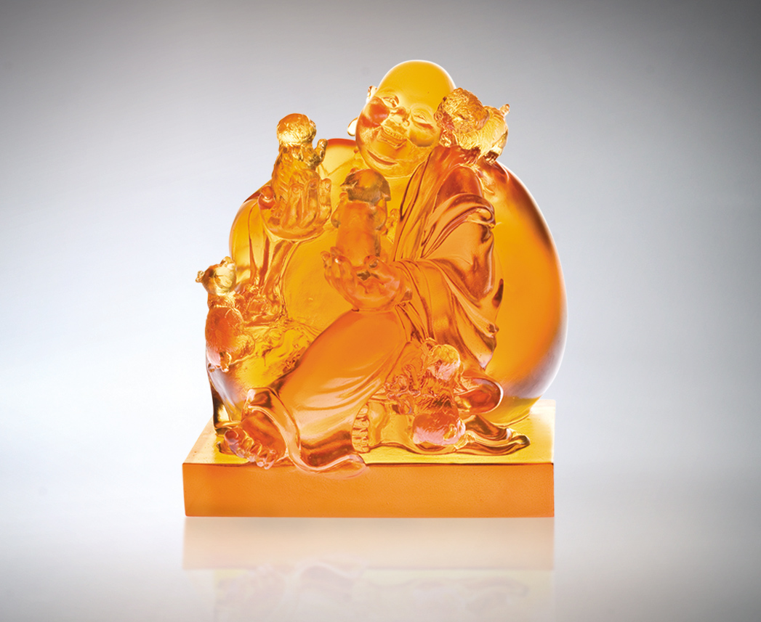
開懷放空 無限接納
不設限 真誠共榮
不計較 歡喜分享
懂得感謝懂得欣賞
芬芳友誼前簇後擁
你呼我應不可開交
抱得滿懷人和昌旺
Boundless Fortune
Open your arms and let your self go! Join the celebration without restraint; Share your happiness without reserve. When you learn the true meaning of Gratitude and appreciation, Friends of love and care will gather To fill your life with wonder.

編號 | 1552283 | No | 1552283
名稱 | 開懷昌旺 | Name | Boundless Fortune
顏色 | 琥 | Color
尺寸 | 13.6 * 13.7 * 15.3 | Size | 13.6 * 13.7 * 15.3
重量 | 2.95 | Weight | 2.95
限量 | O | Limited Edition | O
售價 | NT$ 16800 | Price | NT$ 16800
 | RMB$ 4222 |  | RMB$ 4222

