齊飛揚 | 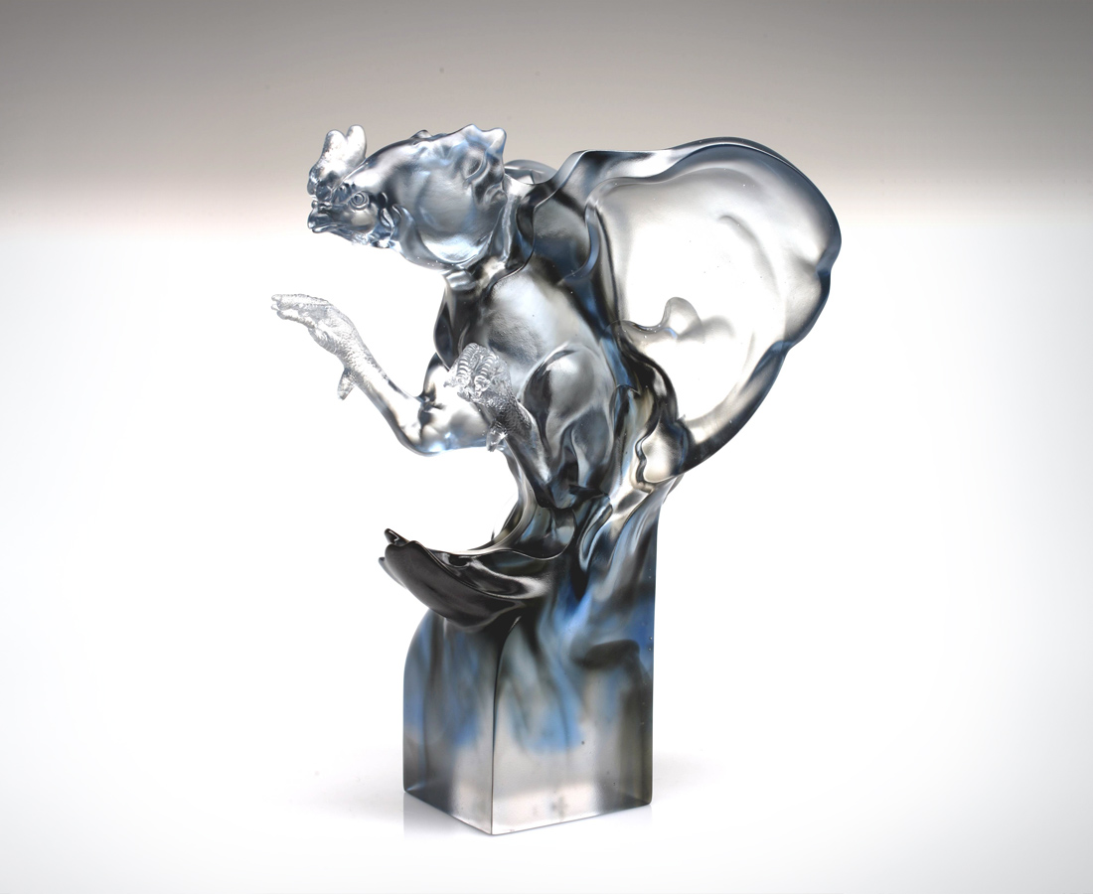
擺脫地心引力的慣性
在高處
張開蓬勃的信心
鼓舞樂觀的朝氣
從裡到外 由心至身
每一根筋骨
展現生命高昂的活力
每一寸肌膚
照耀積極美麗的光輝
齊飛揚 捲起風雲
為美好機會精準出擊
Soar to Great Heights
Denounce the gravitational pull of security Stand tall and high With limitless confidence and courage Celebrate the passion and commitment of optimism That runs through the entire body Through every bone and sinew Emanating the energy and power of life Every inch of skin Glowing with radiant rays of breathtaking beauty Soar to great heights and stir up a storm Preparing to meet the challenges of the future

編號 | 1552172 | No | 1552172
名稱 | 齊飛揚 | Name | Soar to Great Heights
顏色 | 藍灰透 | Color
尺寸 | 19 * 19.5 * 27.4 | Size | 19 * 19.5 * 27.4
重量 | 4.9 | Weight | 4.9
限量 | O | Limited Edition | O
售價 | NT$ 38800 | Price | NT$ 38800
 | RMB$ 9688 |  | RMB$ 9688

