好機緣 | 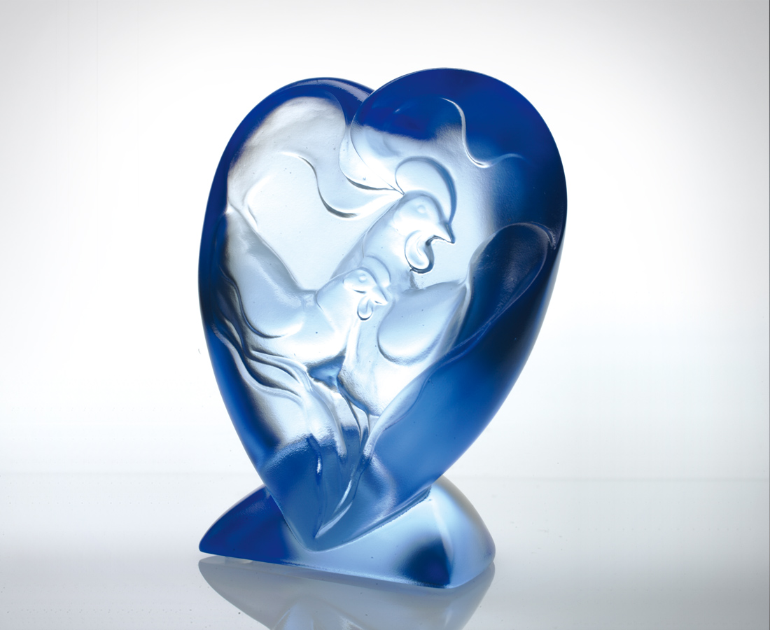
共識真好
方向一同 目標一致
一秒不差的和諧共鳴
共振出好事連連的歡愉
關愛真好
你走我跟 我說你聽
分秒不離的體貼呵護
滋養出花開燦爛的信心
好機緣 二人一體
徜徉愛的好漣漪
Enchanting Alliance
Being of one mind is a beautiful thing With one common goal, moving in one direction Always in collaboration, never distracted even for one second Building an unending stream of happiness Caring for one another is a beautiful thing Me following in your footsteps, you listening attentively when I speak Caring for each other and never leaving each other’s sight for one second, Cultivating an overflow of confidence Enchanting alliance; two bodies of one mind Exuding the rippling effect of love

編號 | 1552166 | No | 1552166
名稱 | 好機緣 | Name | Enchanting Alliance
顏色 | 藍 | Color
尺寸 | 5.4 * 8.3 * 10.5 | Size | 5.4 * 8.3 * 10.5
重量 | 0.6 | Weight | 0.6
限量 | X | Limited Edition | X
售價 | NT$ 4880 | Price | NT$ 4880
 | RMB$ 1222 |  | RMB$ 1222

