風華一世 | 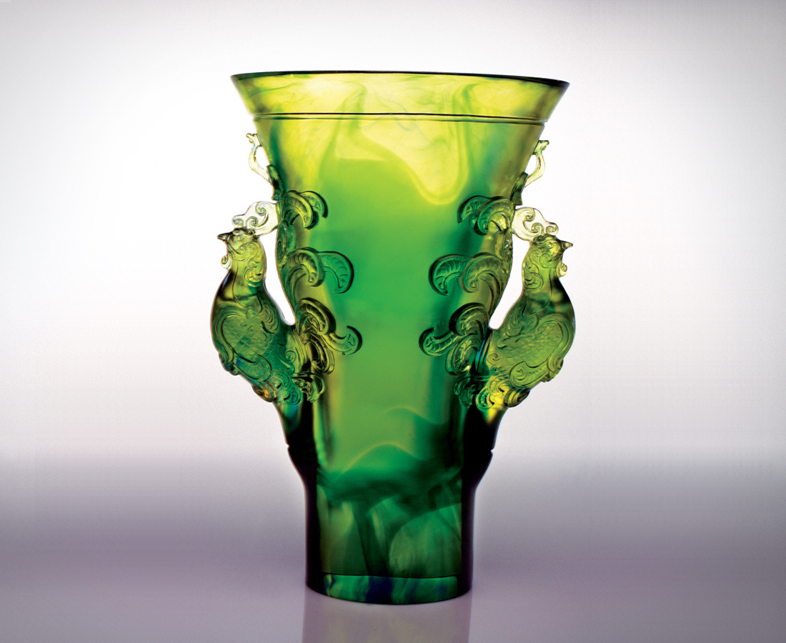
日積月累 橫越東西
集千錘百煉專業本事
見多識廣 穿梭古今
成知所進退圓融心胸
而再展磊落尊貴的氣魄
而挺起洞悉天機的氣勢
而進入風華一世的典範
Charisma and Talent Forever
Continuously accumulating, anytime, anywhere Myriad experiences and skills Cultivating an in-depth knowledge and open-mindedness Once again demonstrating dignified uprightness And relentless pursuit of opportunities Creating a culture of charisma and talent.

編號 | 1552160 | No | 1552160
名稱 | 風華一世 | Name | Charisma and Talent Forever
顏色 | 金藍綠 | Color
尺寸 | 28.5 * 17.5 * 36 | Size | 28.5 * 17.5 * 36
重量 | 12.5 | Weight | 12.5
限量 | O | Limited Edition | O
售價 | NT$ 188600 | Price | NT$ 188600
 | RMB$ 42000 |  | RMB$ 42000

