翠啼春曉 | 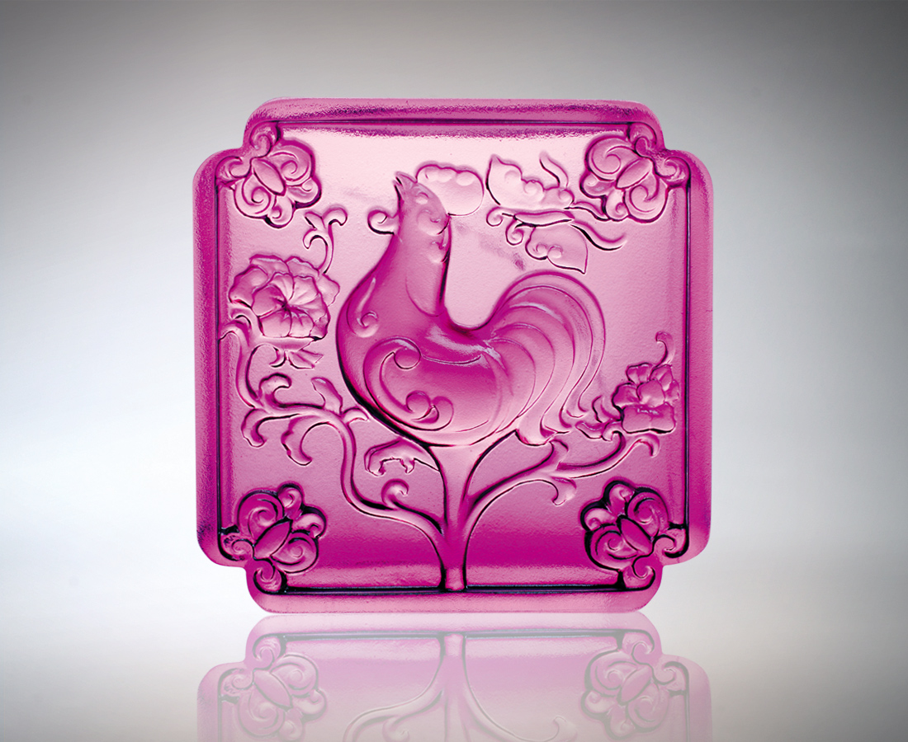
曙光啼醒大地
花隨春暖而開
蝶逐芬芳而來
因緣和合的曼妙天成
沒有遲疑 沒有等待
翠啼春曉 瀲灩璀璨
把握每個美好的開始
Spring Awakening
The rising sun rouses the earth Flowers bloom in the spring warmth Their fragrance attracting a multitude of butterflies The wonders of nature’s perfect matches No delays, no waiting The awakening call of Spring brings a myriad promises Relish and treasure each moment of opportunity

編號 | 1552159 | No | 1552159
名稱 | 翠啼春曉 | Name | Spring Awakening
顏色 | 琥 / 紫 | Color
尺寸 | 3.3 * 7.5 * 7.5 | Size | 3.3 * 7.5 * 7.5
重量 | 0.53 | Weight | 0.53
限量 | X | Limited Edition | X
售價 | NT$ 3580 | Price | NT$ 3580
 | RMB$ 888 |  | RMB$ 888

