吉尊雍容 | 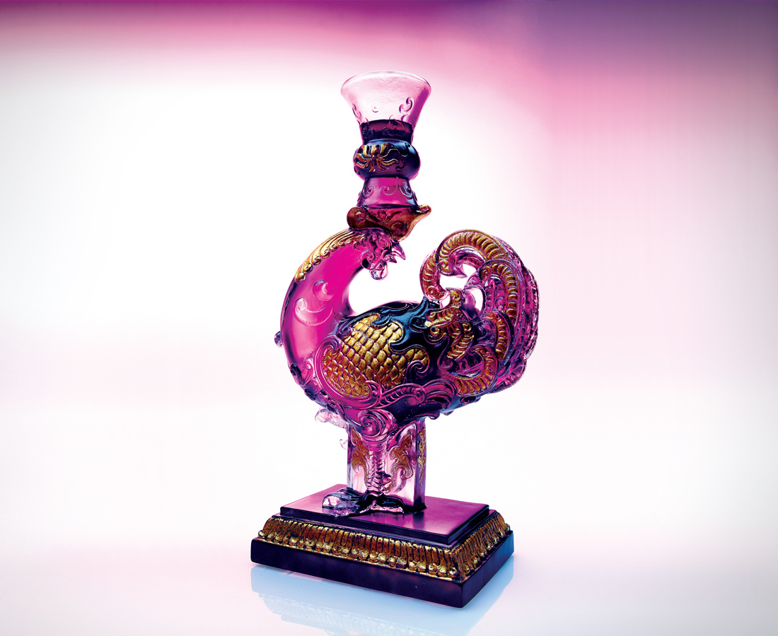
一種莊重
堅守優秀巨匠傳統精神
一股自信
不停學習歷史經典雍容
一番風雅
深耕建構民族文化意象
而溫故知新
為典雅再邁大步
為千年讚歎的尊嚴風華精進
Dignified Glory
Respectful and dignified Jealously guarding our traditions Quietly confident Continuously learning from history’s lessons Tasteful and elegant Refining our cultural perspective Preserving the old yet embracing the new Striding towards elegance and taste Celebrating the dignity of a thousand-year-old culture

編號 | 1552158 | No | 1552158
名稱 | 吉尊雍容 | Name | Dignified Glory
顏色 | 紫+金箔 | Color
尺寸 | 8.5 * 15 * 26.5 | Size | 8.5 * 15 * 26.5
重量 | 2.73 | Weight | 2.73
限量 | O | Limited Edition | O
售價 | NT$ 45600 | Price | NT$ 45600
 | RMB$ 11422 |  | RMB$ 11422

