日月光華 | 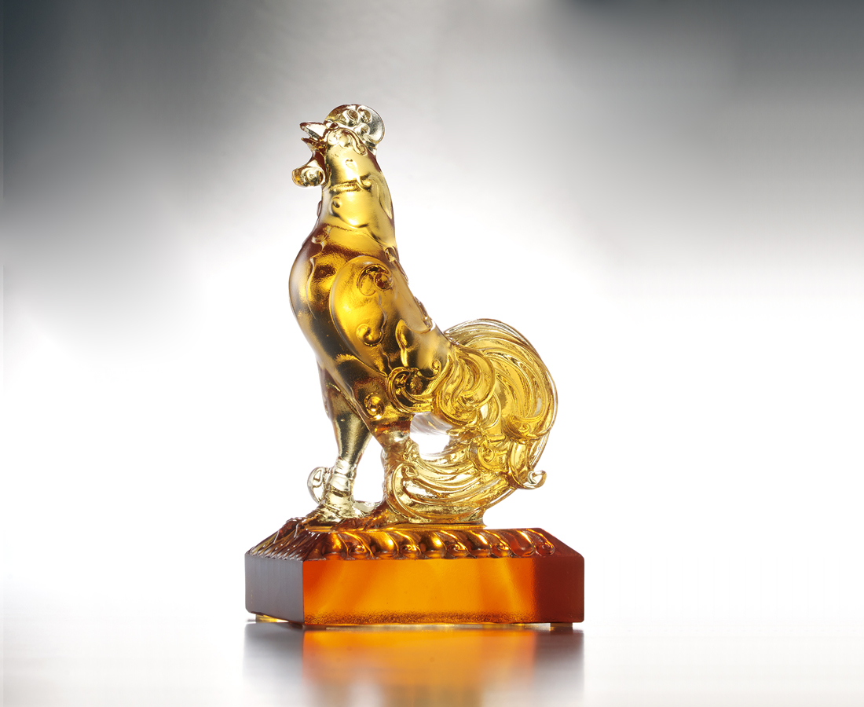
不拘小節 不懼風雨
神聖的視野
莊嚴的心胸
昂然歷史典範的軌跡
豎起時代新猷的使命
以日月之光 以天地之名
為繼往開來立標竿
為璀璨一生挺胸膛
Radiant glory
Magnanimous and courageous With a spirited and far-reaching outlook Passion and earnest commitment Following the trail and lessons learnt of history Shouldering the responsibility of creating a new era Leveraging the power of the Universe Laying the foundation for a better future Creating a life of honor and glory

編號 | 1552156 | No | 1552156
名稱 | 日月光華 | Name | Radiant glory
顏色 | 深琥淺琥 | Color | amber
尺寸 | 7 * 9 * 15 | Size | 7 * 9 * 15
重量 | 1.0 | Weight | 1.0
限量 | X | Limited Edition | X
售價 | NT$ 6280 | Price | NT$ 6280
 | RMB$ 1566 |  | RMB$ 1566

