一枝獨秀 | 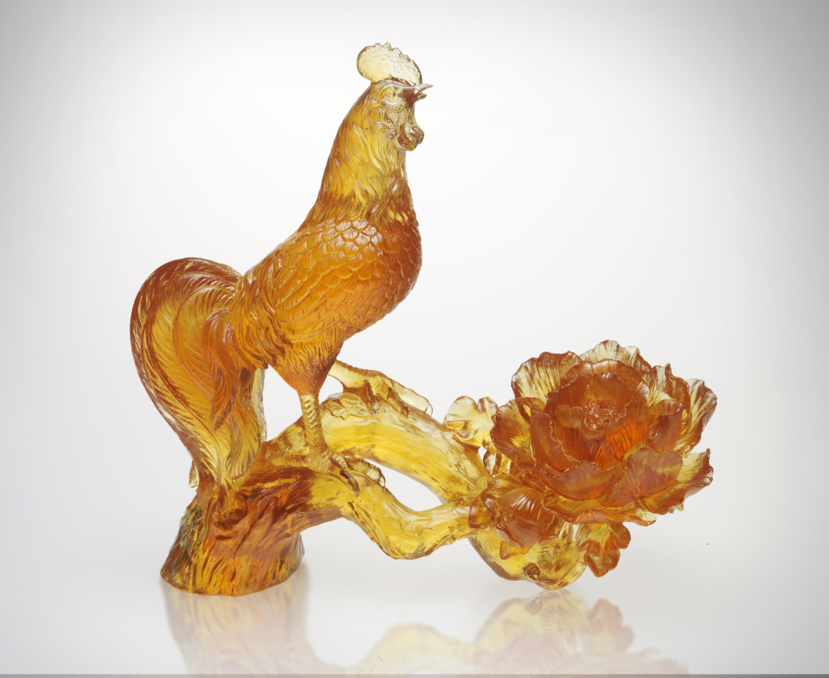
少一點是非長短
多一點時間空間
少一點人云亦云
多一點獨立心思
感受心中激情
感知環境溫度
做最本份的努力
做最燦爛的綻放
一樣自信 一樣富貴
一鳴驚人 一枝獨秀
Lone Achiever
A little less senseless gossip A little more time and space for oneself A little less of going with the flow A little more of individualistic thinking Feel the passion within Understand the environment around you Strive to the best of your ability To achieve the utmost glory with confidence and richness Surprising everyone, the lone achiever

編號 | 1552152 | No | 1552152
名稱 | 一枝獨秀 | Name | Lone Achiever
顏色 | 金紅／金琥 | Color
尺寸 | 8 * 18.5 * 17 | Size | 8 * 18.5 * 17
重量 | 1.1 | Weight | 1.1
限量 | O | Limited Edition | O
售價 | NT$ 17800 | Price | NT$ 17800
 | RMB$ 4466 |  | RMB$ 4466

