歡喜人間 | 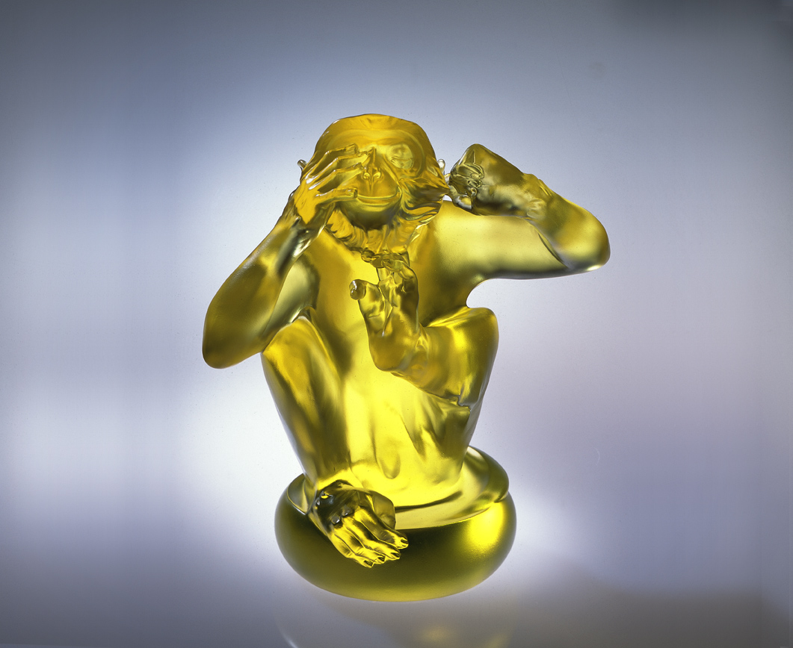
不看高低
福份公平 隨性圓滿
不聽是非
業報公正 因果論斷
不道長短
誠信公開 克己復禮
對人坦盪無私
對事客觀理性
對己謹守忠義
而有了一片人間淨土
The Happy Human Life
Don't review whose superiority or inferiority Welfare is fairness as perfection as personality Don’t be influenced by worldly wrong or right Karma is justified and causality proves to be exact Don't judge one's advantage or weakness Faithfulness and openness to the publics And subject one to observe the proprieties Broadmindedness and Selflessness to treat anybodies With objectivity and rationality in dealing any affairs Strictly adhere to the righteousness in personal action Coordinate with the peoples to establish a pure nation

編號 | 1552054 | No | 1552054
名稱 | 歡喜人間 | Name | The Happy Human Life
顏色 | 金／灰透 | Color
尺寸 | 16.5 * 23.5 * 26 | Size | 16.5 * 23.5 * 26
重量 | 7.69 | Weight | 7.69
限量 | O | Limited Edition | O
售價 | NT$ 39800 | Price | NT$ 39800
 | RMB$ 9966 |  | RMB$ 9966

