高站頭籌 | 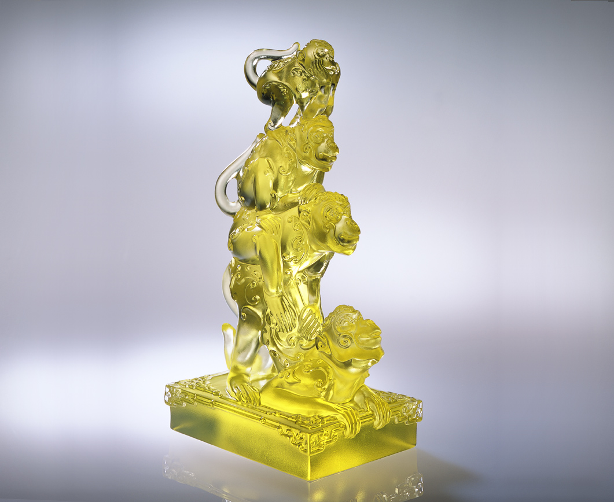
輕撫祖輩
深刻福祿壽喜堆疊的履歷
細讀功成名就不變的守則
福 慈悲喜捨的智慧
祿 求新求變的實踐
壽 恰如其份的修身
禧 通達事理的養性
代代期許 福報日大
輩輩堅守 風範永續
而繼往開來高站頭籌
Outstanding
Softly touch our ancestors A history containing happiness, prosperity, longevity and joys A never-changed rule of success Happiness is the wisdom of benevolence Prosperity is the practice of creations Longevity is the proper self-examination of the mind Joys is the sensible cultivation of the mind The expectation and repayment of happiness from generation to generation The fortitude and incorruptibility from generation to generation Outstandingly carry forward the past and forge ahead into the future

編號 | 1552038 | No | 1552038
名稱 | 高站頭籌 | Name | Outstanding
顏色 | 金 | Color
尺寸 | 11.5 * 8.4 * 21.8 | Size | 11.5 * 8.4 * 21.8
重量 | 2.31 | Weight | 2.31
限量 | O | Limited Edition | O
售價 | NT$ 18600 | Price | NT$ 18600
 | RMB$ 4666 |  | RMB$ 4666

