代代風華 | 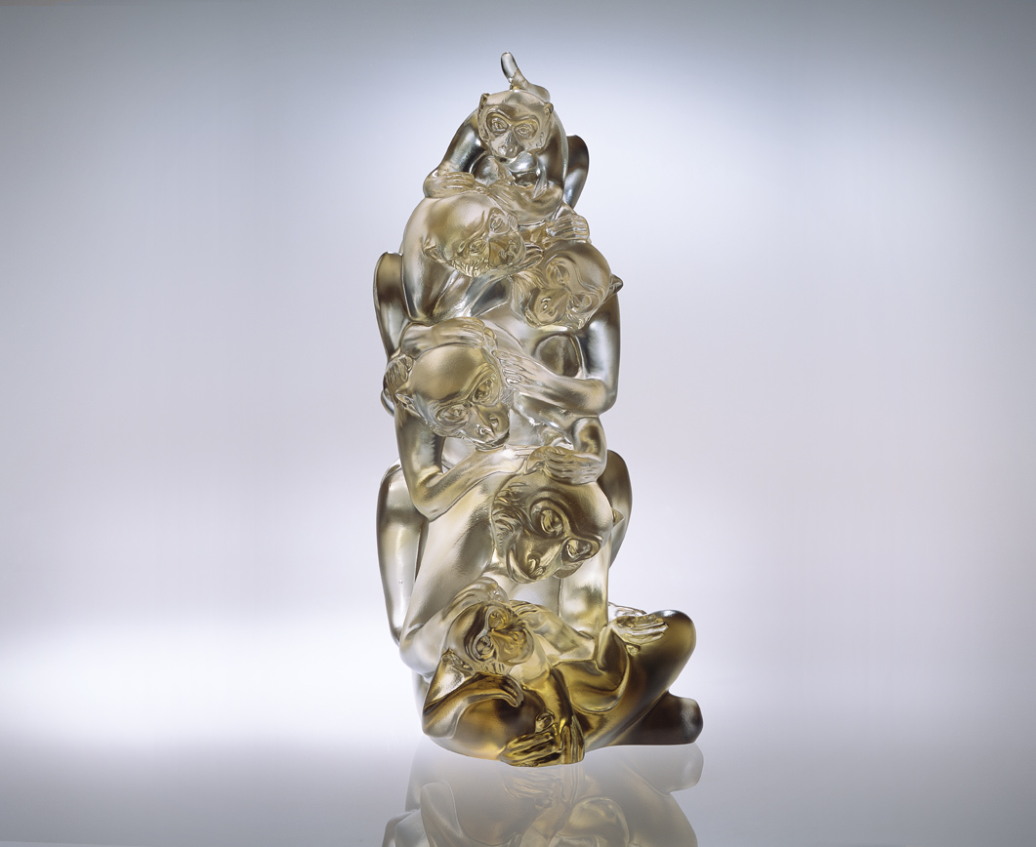
為祖輩風華費心埋頭
用心掏盡 虛心咀嚼
為子孫傳承盡心耕耘
全心開括 細心堅持
信念一致 上下齊心
前後同心 一絲不茍
絕活永續 智慧連綿
期許
輩輩登高 絕色代代
Generational Elegance
For the ancestor's elegance puts much emphasis. To exhaust efforts digests the essential inheritance. For the descendant’s transfer strives to cultivate With a broad mind and care continue to orientate. Through consistent conviction and similar mind, And base upon the same thinking in the blood. Without least negligent to sustain and last wisdom. Anticipate The descendants will obtain glory every generation. And they will become more beautiful in later time.

編號 | 1552037 | No | 1552037
名稱 | 代代風華 | Name | Generational Elegance
顏色 | 茶透 | Color
尺寸 | 12 * 8.5 * 19.7 | Size | 12 * 8.5 * 19.7
重量 | 1.82 | Weight | 1.82
限量 | O | Limited Edition | O
售價 | NT$ 16800 | Price | NT$ 16800
 | RMB$ 4188 |  | RMB$ 4188

