舞動吉慶 | 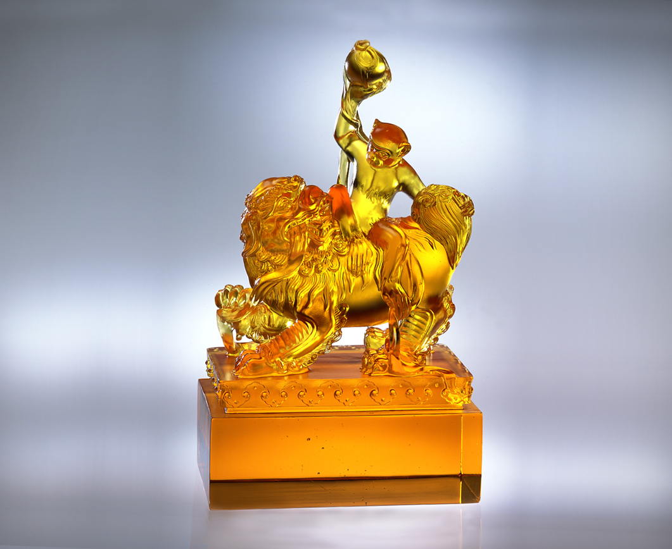
力氣雖有大小
信心以小搏大
經驗雖有多少
智慧以少勝多
四體常勤
挑動一成不變的僵局
心思常用
創造靈活新鮮的佈局
推陳出新 希望繽紛
一片吉慶 風采飛舞
Dancing with Auspice and Happiness
No matter how powerful the physical strength is Confidence is the great No mater less or much the experience is Wisdom is the great With regular physical exercise To break through the stalemate With regular thinking To create a new aspect Endless creations with hope Dancing with auspice and happiness

編號 | 1552014 | No | 1552014
名稱 | 舞動吉慶 | Name | Dancing with Auspice and Happiness
顏色 | 琥 | Color
尺寸 | 7.4 * 12.4 * 21.2 | Size | 7.4 * 12.4 * 21.2
重量 | 2.78 | Weight | 2.78
限量 | O | Limited Edition | O
售價 | NT$ 18800 | Price | NT$ 18800
 | RMB$ 4688 |  | RMB$ 4688

