富貴上菜 | 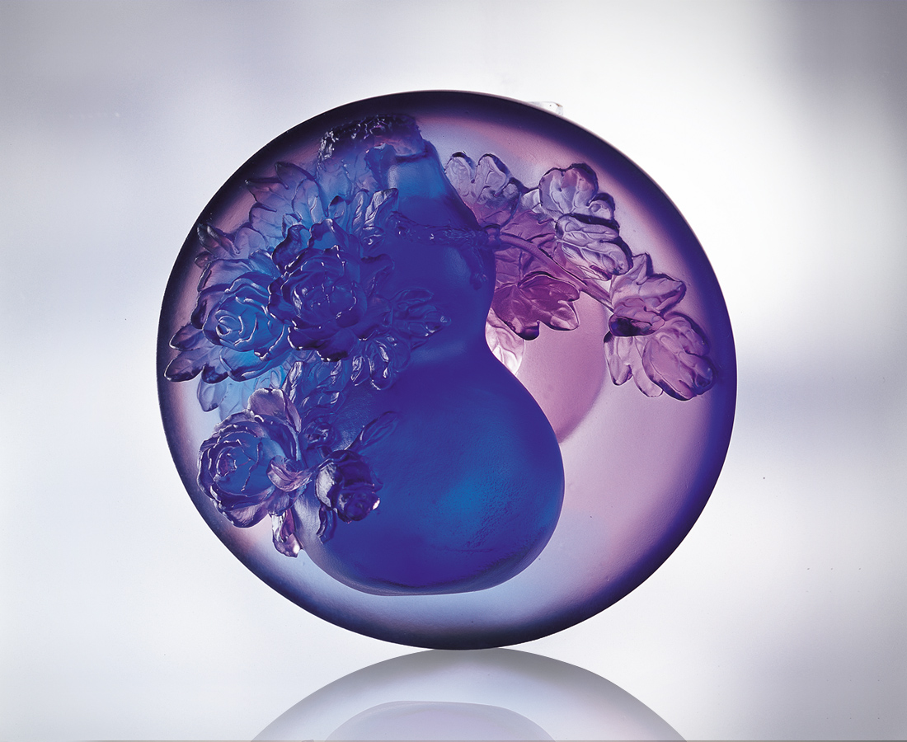
水晶 光彩晶瑩
牡丹 國色天香
葫蘆 淡雅恬美
色香味俱全的拼盤
端詳精緻雍容的福氣
福份延伸富足
壯碩修出細膩
精雕細琢的生活心思
料理莊重自得的一世
Rich and Honorable Fare
Glass…gleaming and flashing; Peonies…heavenly fragrance, the national flower; Gourds…simple understated sweetness: Dishes with full color, aroma, and taste; Serving exquisite graceful blessings. Blessings extend plenty, And substance decorates delicacy; Finely honed reflections on living, A complacent life with solemn fare.

編號 | 1550091 | No | 1550091
名稱 | 富貴上菜 | Name | Rich and Honorable Fare
顏色 | 藍紫透 | Color
尺寸 | 10 * 10 * 7 | Size | 10 * 10 * 7
重量 | 0.52 | Weight | 0.52
限量 | O | Limited Edition | O
售價 | NT$ 4280 | Price | NT$ 4280
 | RMB$ 1088 |  | RMB$ 1088

