福壽圖 | 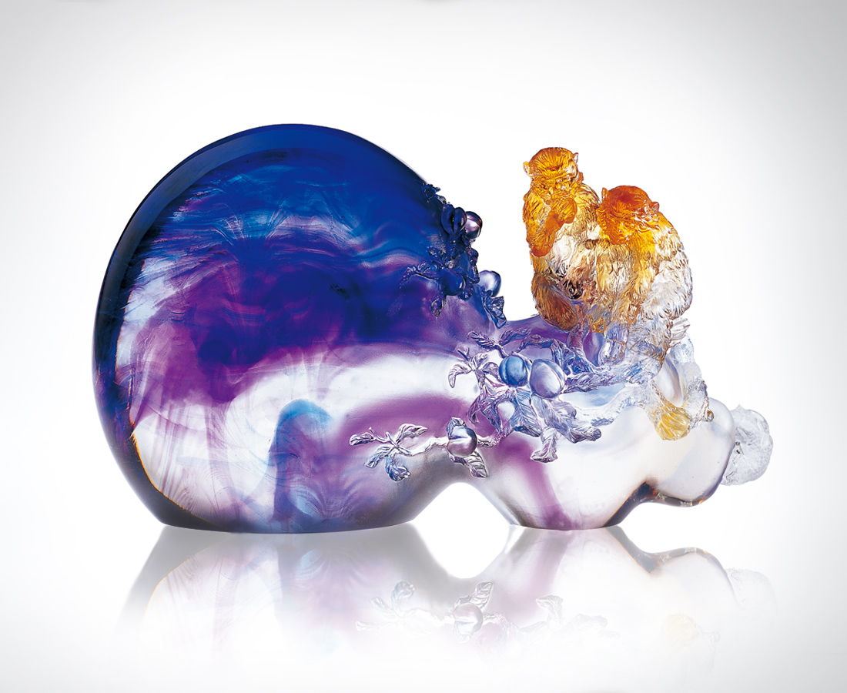
垂手可得的福壽善果
不是無名的天賜恩典
豐碩圓熟的玲瓏形式
是攀爬擴張實行
光合作用的努力
虆虆結實的遍佈歡欣
是一寸一尺積極
深入泥土的滋潤
福大壽多是耕耘的果然
Happiness and Longevity Come in Pairs
Good outcome of happiness and longevity at hand is not unknown blessing from heaven; Fruitful, mature and delicate form derives from photosynthesis of climbing and expansion; Joy from bumper fruit is attributed to the moisture deep in the soil inch by inch; Overwhelming happiness and longevity are the inevitable outcome f cultivation.

編號 | 1550042 | No | 1550042
名稱 | 福壽圖 | Name | Happiness and Longevity Come in Pairs
顏色 | 藍紫透 | Color
尺寸 | 10.6 * 31.5 * 20 | Size | 10.6 * 31.5 * 20
重量 | 7.84 | Weight | 7.84
限量 | O | Limited Edition | O
售價 | NT$ 53600 | Price | NT$ 53600
 | RMB$ 14588 |  | RMB$ 14588

