花冠喜躍 | 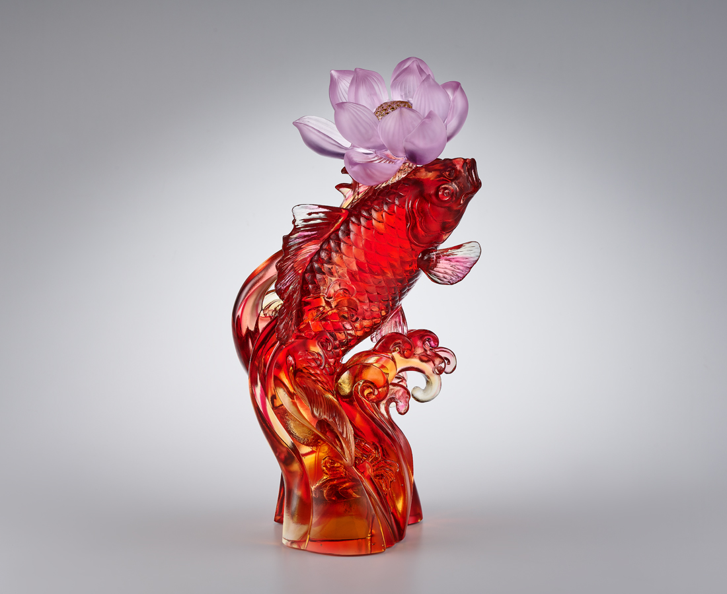
丹曦照染池一方
鼓樂齊鳴醒萬物
客問何處人家報好音
逐浪花 訪碧波
一瞬魚躍 十里荷香
束紅帶 頂花冠
日暖沐春 德馨頌賢
Leap of Joy (Lotus and Carp)
In Chinese, fish is a very popular symbol of good luck, as it has the same pronunciation as "surplus", which means that the fruits of a good harvest can be enjoyed endlessly. The energetic carp jumping out of the water looks as delightful as a lotus flower on its head and has become one of the most auspicious motifs in Chinese culture.

編號 | 1544111 | No | 1544111
名稱 | 花冠喜躍 | Name | Leap of Joy (Lotus and Carp)
顏色 | 粉紅琥紅透+金箔 | Color | pink, amber, clear and gilding
尺寸 | 15.5 * 14.6 * 29 | Size | 15.5 * 14.6 * 29
重量 | 2.9 | Weight | 2.9
限量 | O | Limited Edition | O
售價 | NT$ 30800 | Price | NT$ 30800
 | RMB$ 6850 |  | RMB$ 6850

