繽紛閃耀 | 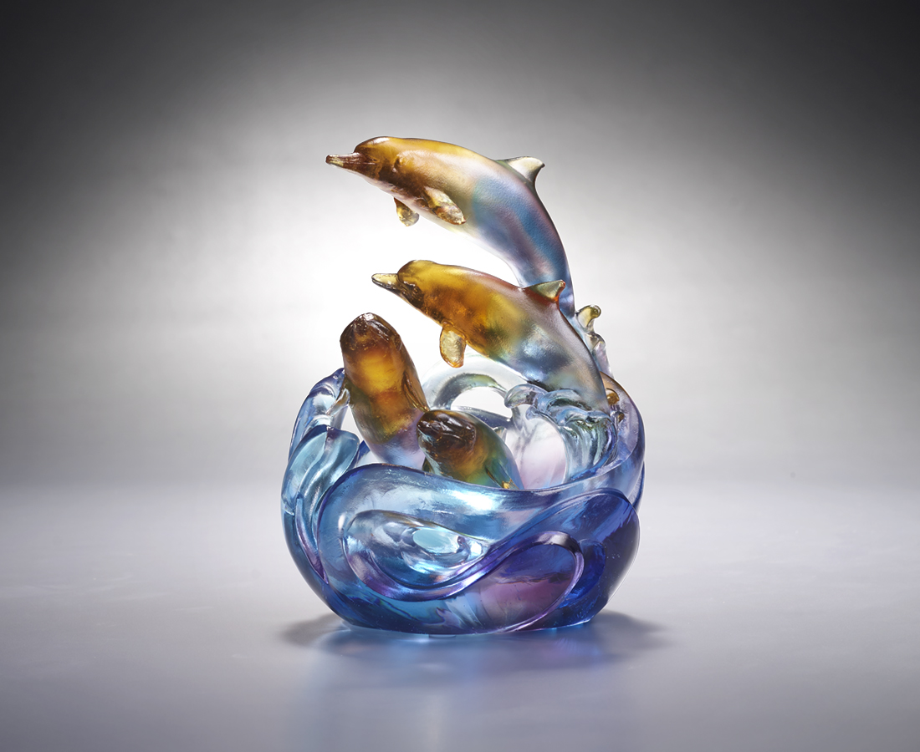
清脆的笑聲
在浪花裡穿梭
騰躍共舞 散發繽紛的光彩
同心協力 成就閃耀的未來
Camaraderie
The artwork conveys that only a clean ocean can sustain the vast amount of lives on this globe, through the imagery of dolphins swimming and having fun in the clear ocean. The dolphins sticking with each other also expresses the virtues of teamwork and partnership.

編號 | 1543946 | No | 1543946
名稱 | 繽紛閃耀 | Name | Camaraderie
顏色 | 藍青琥紫透 | Color | blue, cyan, amber, purple, clear
尺寸 | 10 * 8.5 * 13.5 | Size | 10 * 8.5 * 13.5
重量 | 0.85 | Weight | 0.85
限量 | X | Limited Edition | X
售價 | NT$ 7680 | Price | NT$ 7680
 | RMB$ 1700 |  | RMB$ 1700

