喜樂優游 | 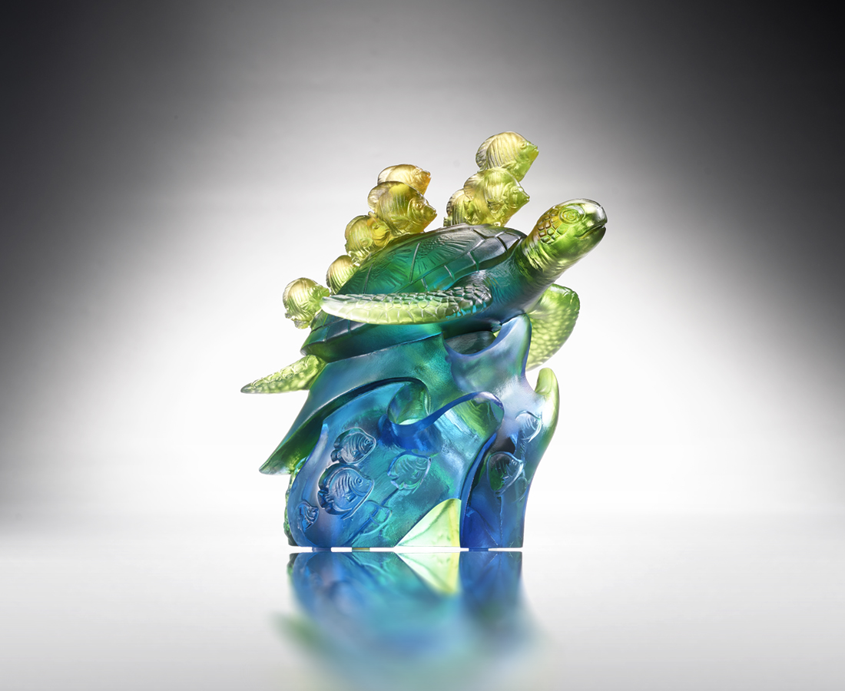
心無掛慮 自由自在
水到渠成 豐收滿載
樂於分享 喜悅常在
充實生活 絢麗多彩
The Art of Cooperation
The artwork highlights the significance of coexistence and co-prosperity in ecosystems with the imagery of sea turtle and tropical fish living together. The imagery also conveys that through cooperation and sharing can multiple parties create a win-win situation.

編號 | 1543945 | No | 1543945
名稱 | 喜樂優游 | Name | The Art of Cooperation
顏色 | 藍綠琥透 | Color | blue, green, amber, clear
尺寸 | 15.5 * 13 * 15.5 | Size | 15.5 * 13 * 15.5
重量 | 1.5 | Weight | 1.5
限量 | O | Limited Edition | O
售價 | NT$ 10800 | Price | NT$ 10800
 | RMB$ 2400 |  | RMB$ 2400

