壯遊天下 | 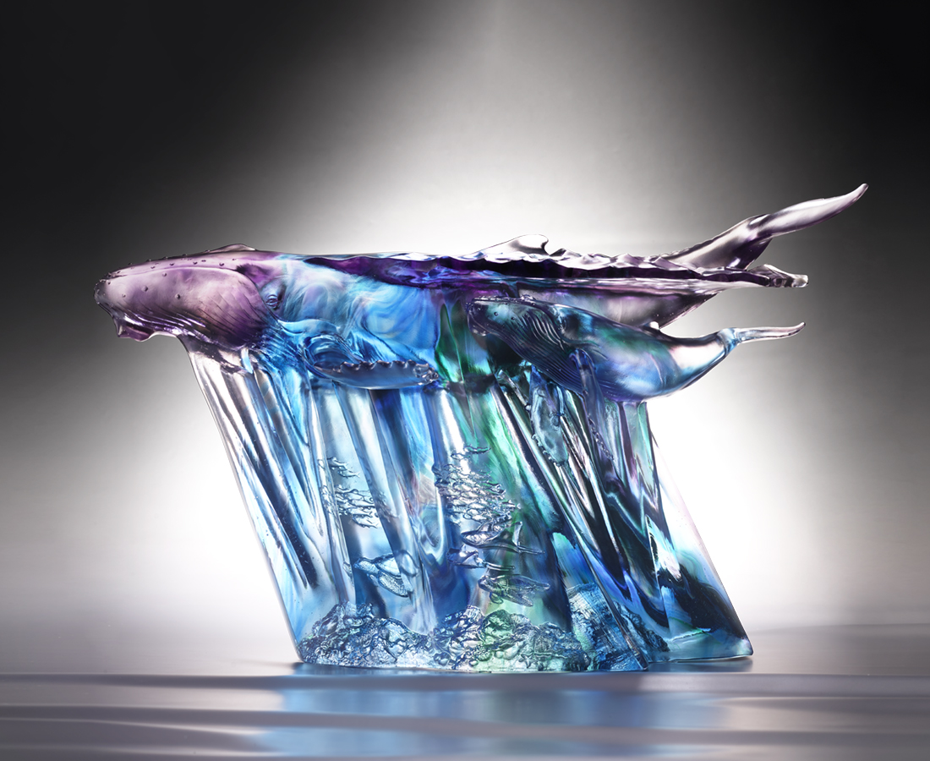
悠揚的歌聲 訴說生命禮讚
耀眼的光芒指引
志向就是方向
挑戰疆界 沒有極限
壯闊視野 精彩無邊
A Journey of Excellence
The artwork depicts the magnificence of a mother and baby humpback whale swimming in the ocean. The ocean below shows the blazing and glaring sunlight penetrating the sea surface. Through the translucency of the colored glass, both the transparency of the ocean water and the abundance of fishes are presented. The artwork conveys that only a clean ocean can sustain the vast amount of lives on this globe. The magnificent presence of the whales in the ocean, on the other hand, expresses virtue of challenging oneself and exceeding expectations.

編號 | 1543944 | No | 1543944
名稱 | 壯遊天下 | Name | A Journey of Excellence
顏色 | 藍青綠紫灰透 | Color
尺寸 | 56 * 37 * 35 | Size | 56 * 37 * 35
重量 | 27.0 | Weight | 27.0
限量 | O | Limited Edition | O
售價 | NT$ 238000 | Price | NT$ 238000
 | RMB$ 52900 |  | RMB$ 52900

