滿載而歸 | 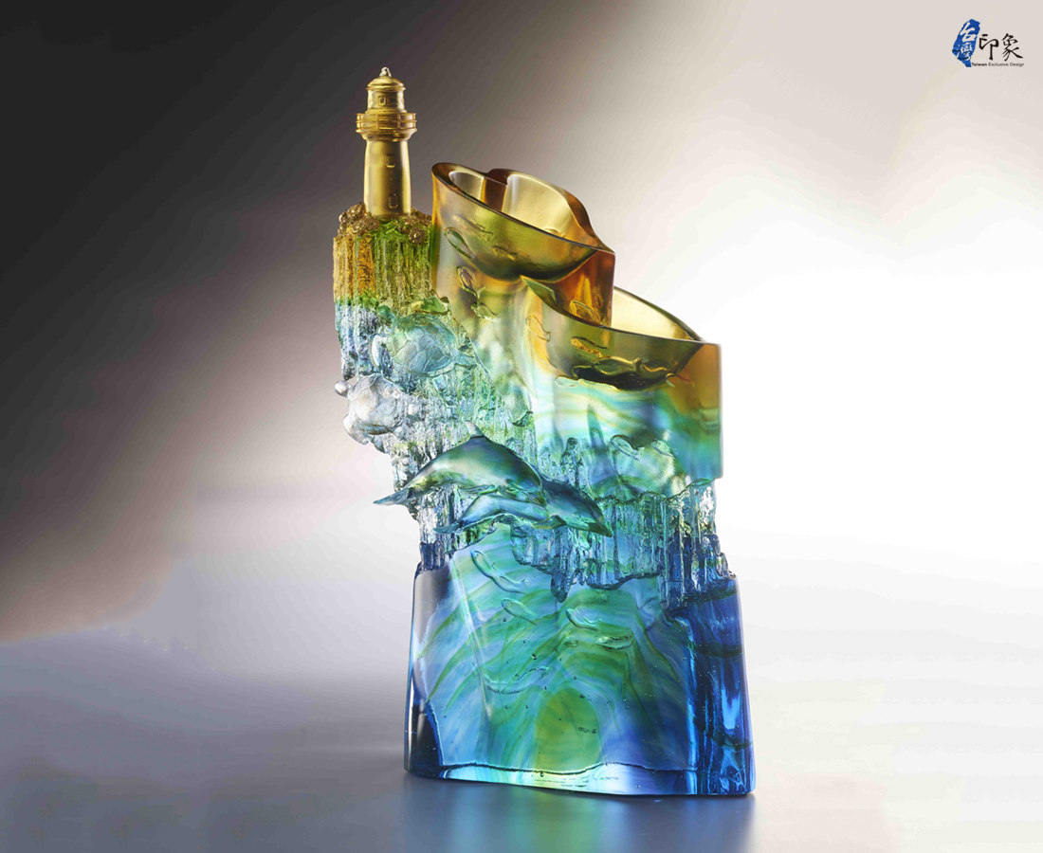
燈塔的光 堅定地牽引波浪
天人菊隨風飛舞
朝著玄武岩傾訴溫柔盼望
海豚帶著清脆的笑聲
捎來豐盛的祝福
漁火聚集 汗水歸返海洋
心連著心
滿載希望
The Penghu Impression
Penghu has long been a famous tourist site located outside of Taiwan mainland. The artwork presents the islands’ unique azure coast, rich fishery products, and the endangered species of green sea turtle, using the geographically abundant basalt rock as its main shape. The top of the artwork is ornamented by Penghu’s attractions: the romantic Twin-hearts Stone Weir and the lighthouse. The entire artwork vividly expresses the vibrant and bubbly sceneries of Penghu as the perfect tourist resort.

編號 | 1543935 | No | 1543935
名稱 | 滿載而歸 | Name | The Penghu Impression
顏色 | 藍青琥綠透+金箔 | Color | blue, cyan, amber, green, clear + Gold l
尺寸 | 18.3 * 10.5 * 29 | Size | 18.3 * 10.5 * 29
重量 | 5.0 | Weight | 5.0
限量 | O | Limited Edition | O
售價 | NT$ 25700 | Price | NT$ 25700
 | RMB$ 5750 |  | RMB$ 5750

