欣欣共榮 | 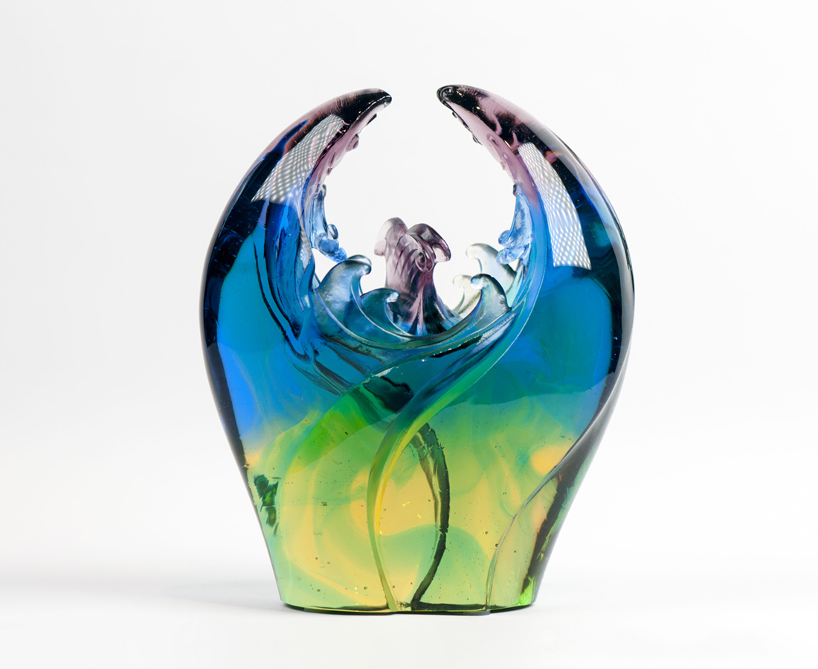
齊心向上 展望天下
鴻圖始駿業 左右逢源
乘風踏浪 航向榮光
礁岩激盪浪花 璀璨綻放
Duet of Fortune and Auspicity
In Chinese culture, the fish is homophonic with abundance. Two fish, on the other hand, express that fortune comes in pairs. The artwork utilizes a design of two fish rising above to encapsulate the duet nature of fortune and auspicity.

編號 | 1543934 | No | 1543934
名稱 | 欣欣共榮 | Name | Duet of Fortune and Auspicity
顏色 | 藍紫金綠透 | Color | blue, purple, golden, green, clear
尺寸 | 12.2 * 6.5 * 15 | Size | 12.2 * 6.5 * 15
重量 | 1.4 | Weight | 1.4
限量 | X | Limited Edition | X
售價 | NT$ 5980 | Price | NT$ 5980
 | RMB$ 1350 |  | RMB$ 1350

