旗開豐年 | 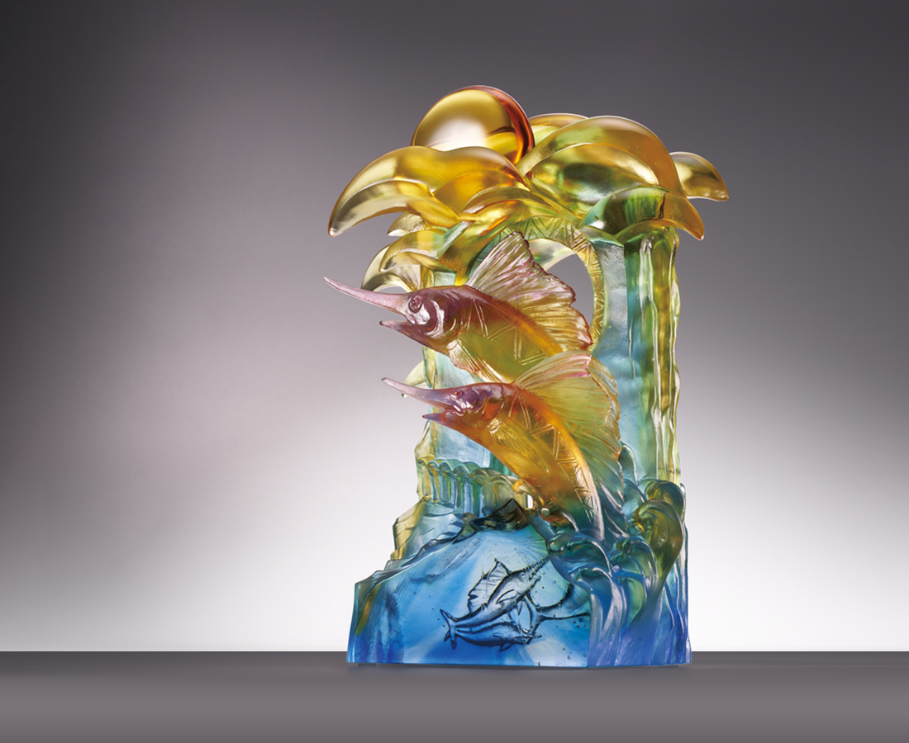
金崙天光 日出豐收
雲端是承載希望的飛翔
古老而渾厚的歌聲穿越蒼穹
歌頌山的壯麗與大海的恩情
旗魚崛起 騰耀豐年
現身美麗傳說的比西里岸
拾起閃爍光芒的稻穗
攜手漫步於綿延的高台
信心望向 美好康莊
The Taitung Impression
Its design based on Taitung's famous sceneries of sunrise and the Pacific, the artwork mingles the tourist destination Sanxiantai, hot air balloons, and symbols of the indigenous culture altogether to portray the fun-filled, tranquilizing impressions of the county. The main character of the artwork, the swordfish, is an accurate emblem of Taitung. The deliberate design of swordfish leaping out of water conveys the hospitality and kindness of Taiwanese.

編號 | 1543923 | No | 1543923
名稱 | 旗開豐年 | Name | The Taitung Impression
顏色 | 琥紫藍綠透 | Color | amber, blue. purple, green, clear
尺寸 | 20.5 * 9.5 * 26.8 | Size | 20.5 * 9.5 * 26.8
重量 | 4.68 | Weight | 4.68
限量 | O | Limited Edition | O
售價 | NT$ 28950 | Price | NT$ 28950
 | RMB$ 6460 |  | RMB$ 6460

