瀲灩風華 | 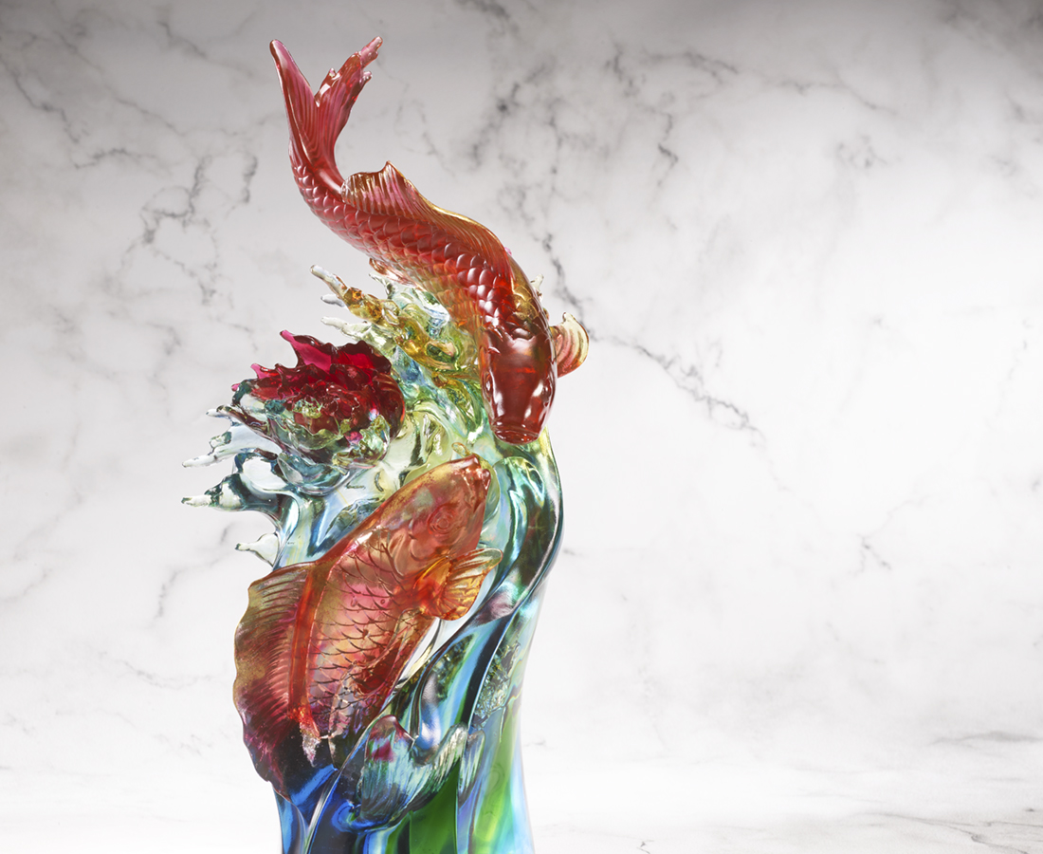
湛藍活水 雍容自得
靈動擺尾 瀲灩華開
金鱗圓滿 榮光奪目
在波光中閃爍
有愉 就有悅
雙雙來報喜
牡丹豐吉祥
濃情富人生
The Koi and Peony
Both the koi and peony symbolizes prestige in the Eastern Culture. The artwork draws inspiration from the Japanese tattoos, or Irezumi, presenting unique aesthetics and elegance of the East with its two main characters.

編號 | 1543915 | No | 1543915
名稱 | 瀲灩風華 | Name | The Koi and Peony
顏色 | 金紅琥藍綠透+金箔 | Color | goden, red, amber, blue. green, clear +
尺寸 | 21.6 * 18.2 * 41 | Size | 21.6 * 18.2 * 41
重量 | 8.2 | Weight | 8.2
限量 | O | Limited Edition | O
售價 | NT$ 88800 | Price | NT$ 88800
 | RMB$ 19780 |  | RMB$ 19780

