優雅現身 | 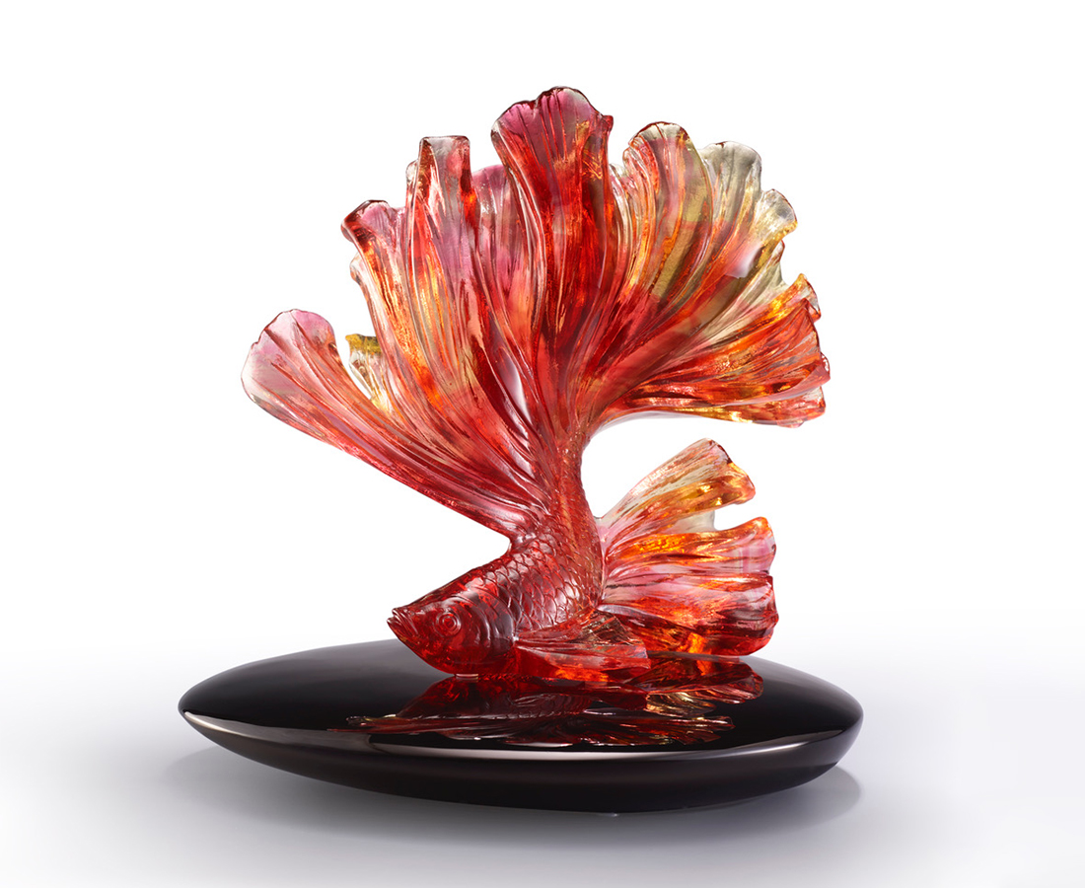
鑼鼓響起 一場好戲
青衣赤裙起舞
優雅現身 一展身手
遨遊萬千世界 寶馬雕車如流水
人生如戲 光輝燦爛
Elegant Guppy
This artwork, designed with pure artistic concepts, utilizes the multiplicity of colors and shades of the colored glass to display the beauty of a guppy. In addition, the unfolded caudal fin of the fish delivers the message of giving it a go on the pathway of life.

編號 | 1543914 | No | 1543914
名稱 | 優雅現身 | Name | Elegant Guppy
顏色 | 琥紅透+黑 | Color
尺寸 | 24 * 20 * 24 | Size | 24 * 20 * 24
重量 | 5.0 | Weight | 5.0
限量 | O | Limited Edition | O
售價 | NT$ 34350 | Price | NT$ 34350
 | RMB$ 7650 |  | RMB$ 7650

