和美有餘 | 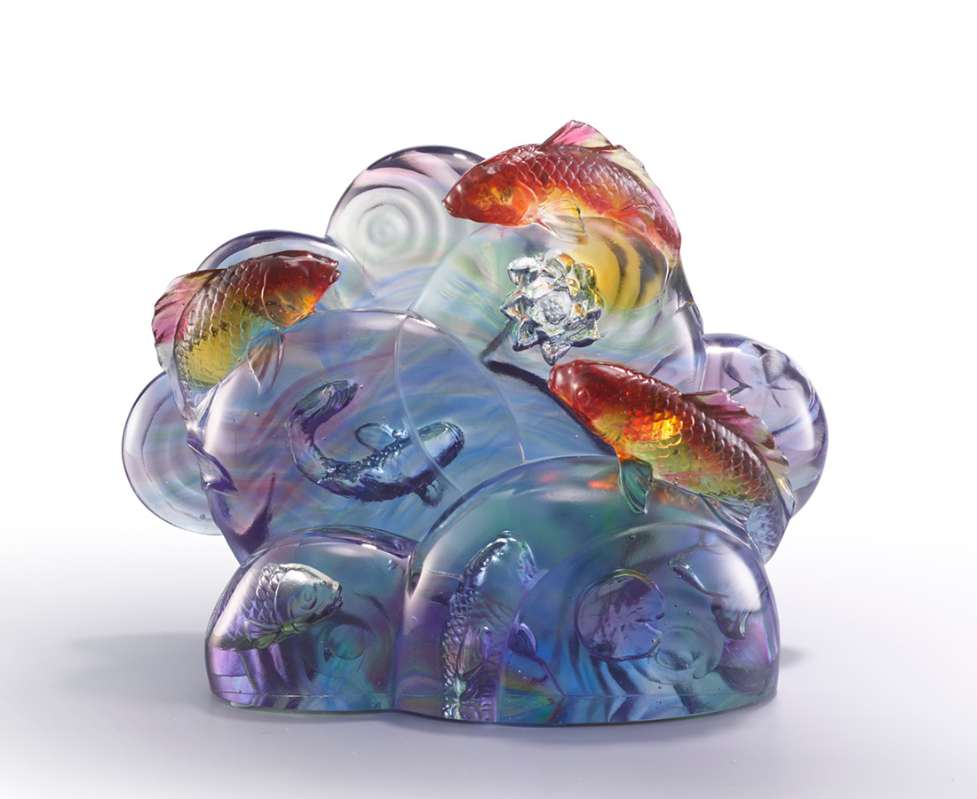
忽而潛入 忽而躍出
水波間 光影爍爍
亦虛亦實 千變又萬化

芙蓉和美 枝葉扶疏
漣漪間 魚影靈動
好一個 魚肥花香 好風光
Carp and Lotus
The artwork, with light being the central element, is produced by a combination of large-scale polishing and engraving. Assembling the light, the artwork appears as if it is the container of light. The other elements, including a lotus and carp, convey the blessings of peace and happiness.

編號 | 1543909 | No | 1543909
名稱 | 和美有餘 | Name | Carp and Lotus
顏色 | 琥紅藍紫綠透 | Color | amber, red, blue. purple, green, clear
尺寸 | 23 * 12 * 27 | Size | 23 * 12 * 27
重量 | 4.7 | Weight | 4.7
限量 | O | Limited Edition | O
售價 | NT$ 29800 | Price | NT$ 29800
 | RMB$ 6650 |  | RMB$ 6650

