花開有餘 | 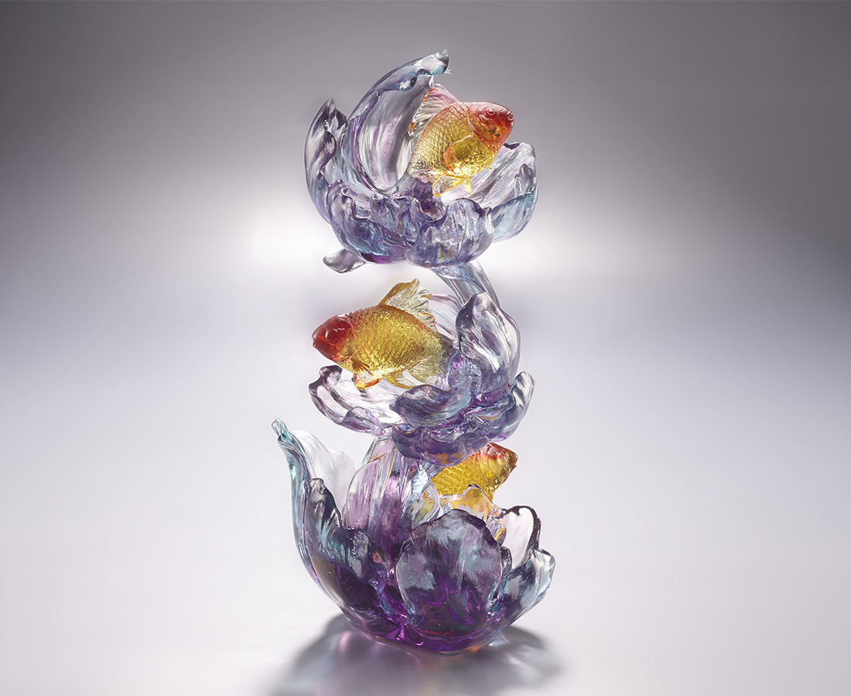
上下游梭，金鳞閃爍
藝花邀蝶也可以邀魚
然後，好好藏收
每一次揭探，盛綻朵朵
Abundant Wealth
Peony is called the flower of wealth in Chinese, symbolizing flourishments and prosperity. Goldfish has its Chinese pronunciation similar to gold and jade. Merging goldfish with the peony, the artwork delivers the blessings of abundant wealth.

編號 | 1543905 | No | 1543905
名稱 | 花開有餘 | Name | Abundant Wealth
顏色 | 青紫琥紅 | Color | Cyan, purple, red, clear
尺寸 | 11 * 12 * 22.5 | Size | 11 * 12 * 22.5
重量 | 1.3 | Weight | 1.3
限量 | X | Limited Edition | X
售價 | NT$ 14990 | Price | NT$ 14990
 | RMB$ 3350 |  | RMB$ 3350

