如魚樂水 | 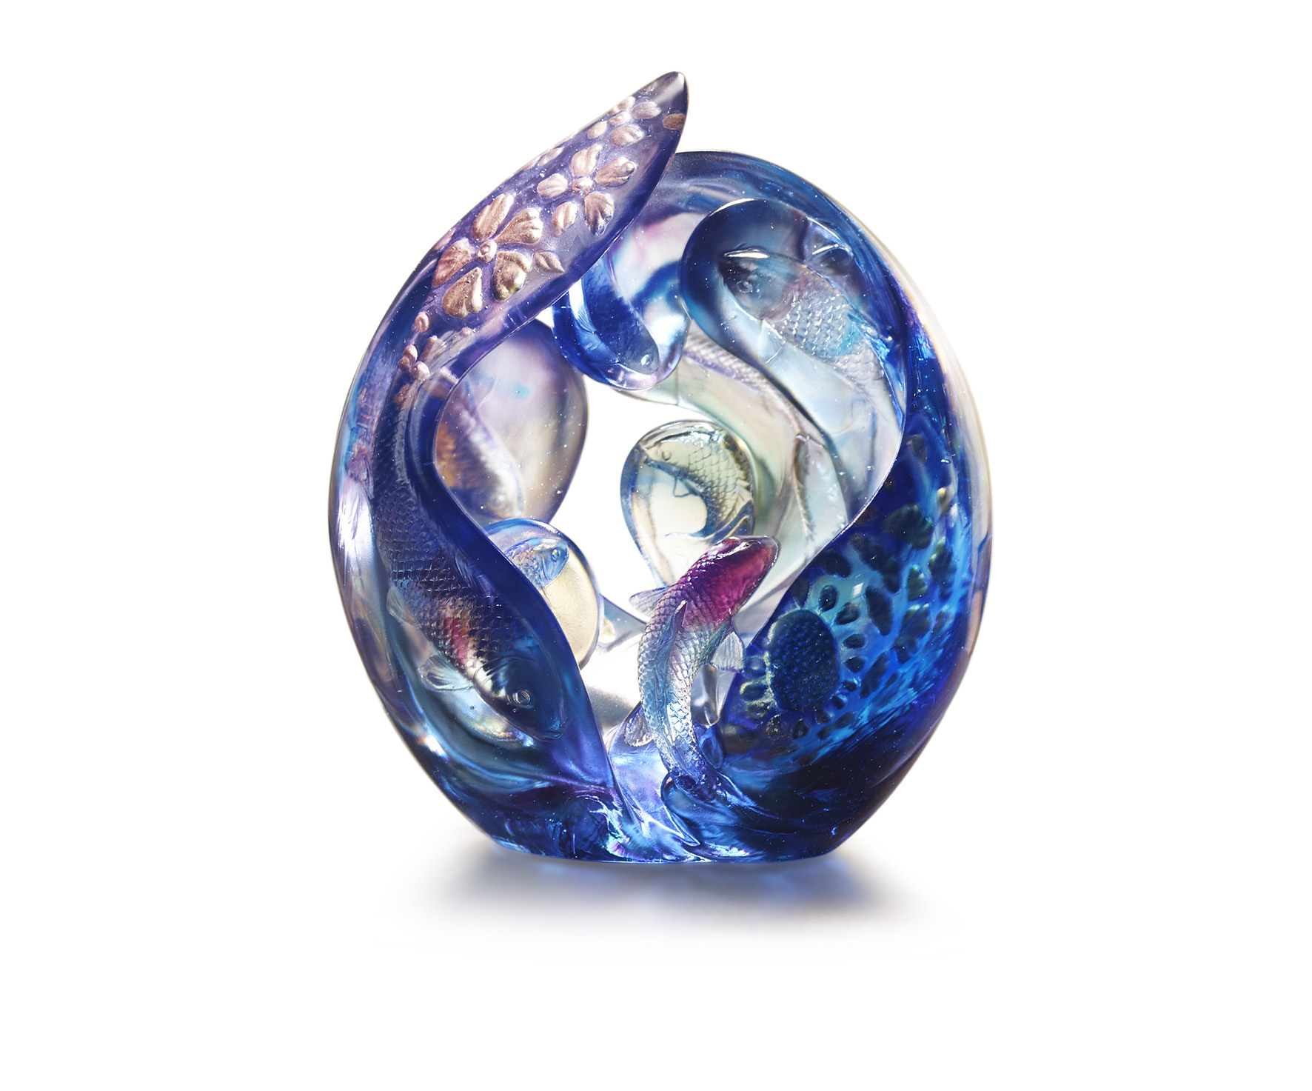
安知魚樂，出遊從容
魚戲蓮葉東，我立天地中
鱗光鑠金，擺尾靈動
三春煙水暖，一躍化神龍
染渲一座藍紫色水晶宮
如魚得水 樂在其中
Koi
The artwork imitates brush painting by crystal glass, presenting the amusing scenery of koi carp leisuring under the lotus leaves. Due to the translucent characteristic and different thickness of crystal glass, the designer creates a peculiar shade of color and infinite depth of field. The curly petals and spiritual koi carp integrates into a sense of harmony and happiness.

編號 | 1543896 | No | 1543896
名稱 | 如魚樂水 | Name | Koi
顏色 | 藍青紫透+金箔 | Color | blue, cyan, amber, clear + gilding
尺寸 | 21.5 * 14.8 * 25.2 | Size | 21.5 * 14.8 * 25.2
重量 | 6.5 | Weight | 6.5
限量 | O | Limited Edition | O
售價 | NT$ 48680 | Price | NT$ 48680
 | RMB$ 10850 |  | RMB$ 10850

