繁榮永續 | 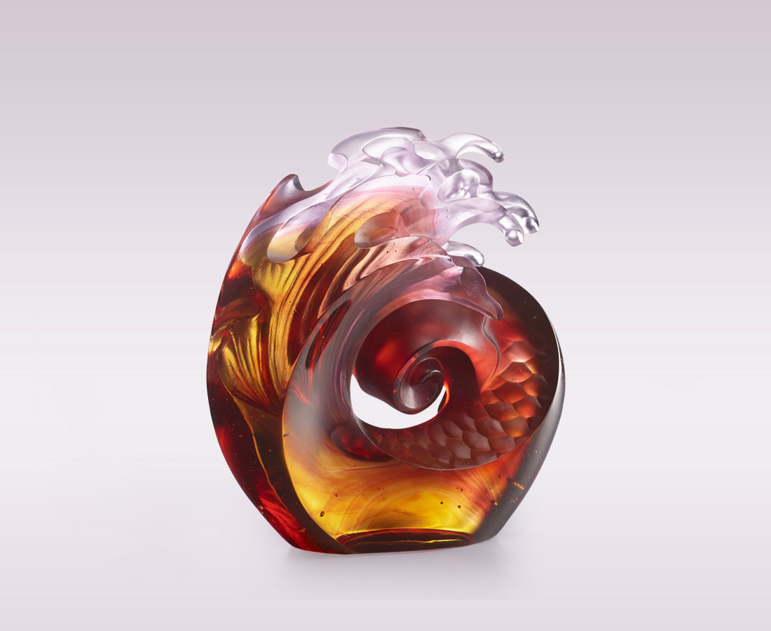
在時間的軸線上
宇宙的循環永不止歇
如同一波波浪潮
帶動生命的誕生
唯有對大地俯首稱臣 謙卑
自然也回饋繁榮永續 滿溢
Endless Growth
The artwork uses design of fish scale as representation of fishes in the ocean. Life begins with the ocean, the twirling waves symbolizes the insignificance of life, along with the message of time elapses, the cycle of universe advances continuously.

編號 | 1543890 | No | 1543890
名稱 | 繁榮永續 | Name | Endless Growth
顏色 | 粉紅紅金透 | Color | pink, red, golden, clear
尺寸 | 14.9 * 5.8 * 16.8 | Size | 14.9 * 5.8 * 16.8
重量 | 1.8 | Weight | 1.8
限量 | X | Limited Edition | X
售價 | NT$ 14990 | Price | NT$ 14990
 | RMB$ 3350 |  | RMB$ 3350

