鴻運昌隆 | 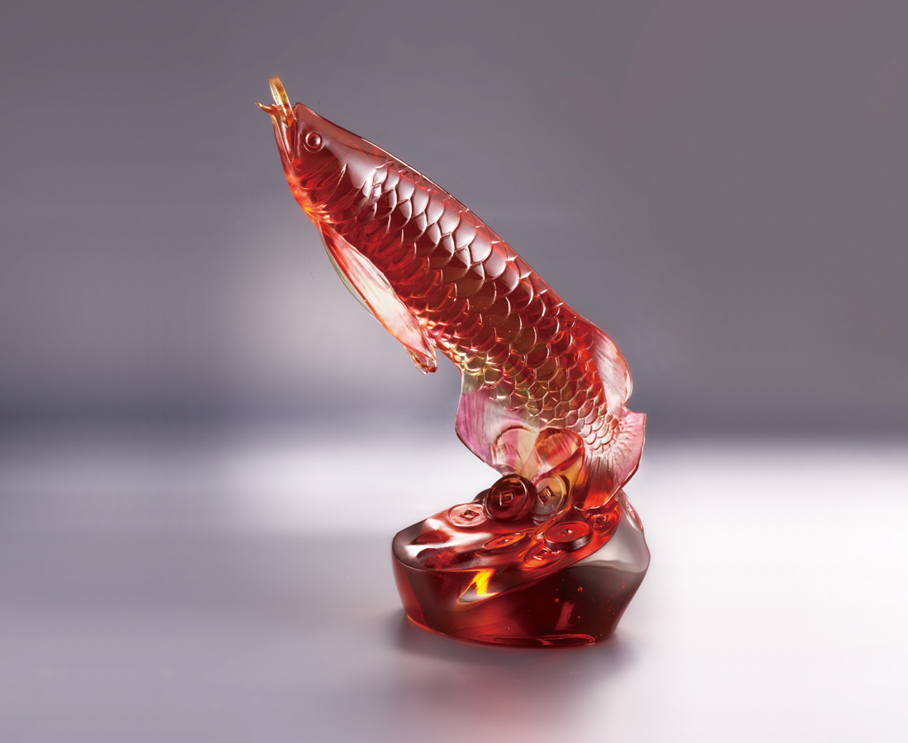
潮流隨時而變
唯有信心不改
生活如魚 順暢無礙
事業得水 源源不絕
身心有餘裕
生活更精彩
The Arowana Fish
The Arowana Fish is an ancient kind of fish, and was considered as a real-life representation of dragon due to its colors. It is popular in the South-Eastern Asia, and is known for a mascot that stimulates career developments and protects families. With its smooth aesthetics, symbolisms of the red-golden color and Arowana Fish reflecting each other, the artwork conveys the blessings of Chinese culture towards life.

編號 | 1543880 | No | 1543880
名稱 | 鴻運昌隆 | Name | The Arowana Fish
顏色 | 金紅透 | Color | golden, red, clear
尺寸 | 13.5 * 9 * 21 | Size | 13.5 * 9 * 21
重量 | 1.3 | Weight | 1.3
限量 | O | Limited Edition | O
售價 | NT$ 13700 | Price | NT$ 13700
 | RMB$ 3080 |  | RMB$ 3080

