如魚得水 | 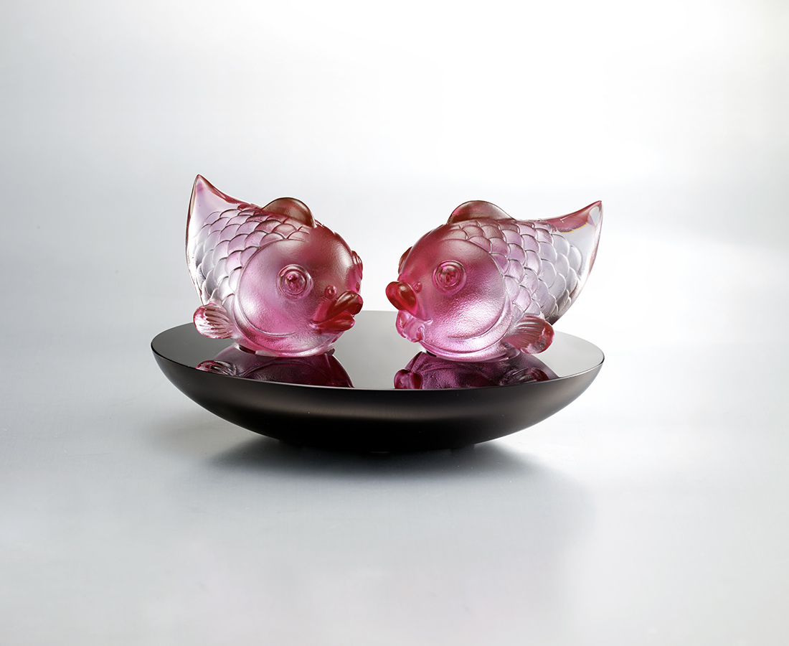
卿卿我我
呢喃一生的喜悅
你我不分 歡喜甘願
悠哉游哉 如魚得水
Like a Fish to Water
Goldfish and water merge into a single entity, symbolizing a meeting with a kindred spirit which makes everything feel smooth and easily attainable.

編號 | 1543780 | No | 1543780
名稱 | 如魚得水 | Name | Like a Fish to Water
顏色 | 紅透＋黑 | Color | red, clear + black
尺寸 | 12.5 * 9.1 * 7.5 | Size | 12.5 * 9.1 * 7.5
重量 | 0.78 | Weight | 0.78
限量 | X | Limited Edition | X
售價 | NT$ 7660 | Price | NT$ 7660
 | RMB$ 1700 |  | RMB$ 1700

