愉躍如意 | 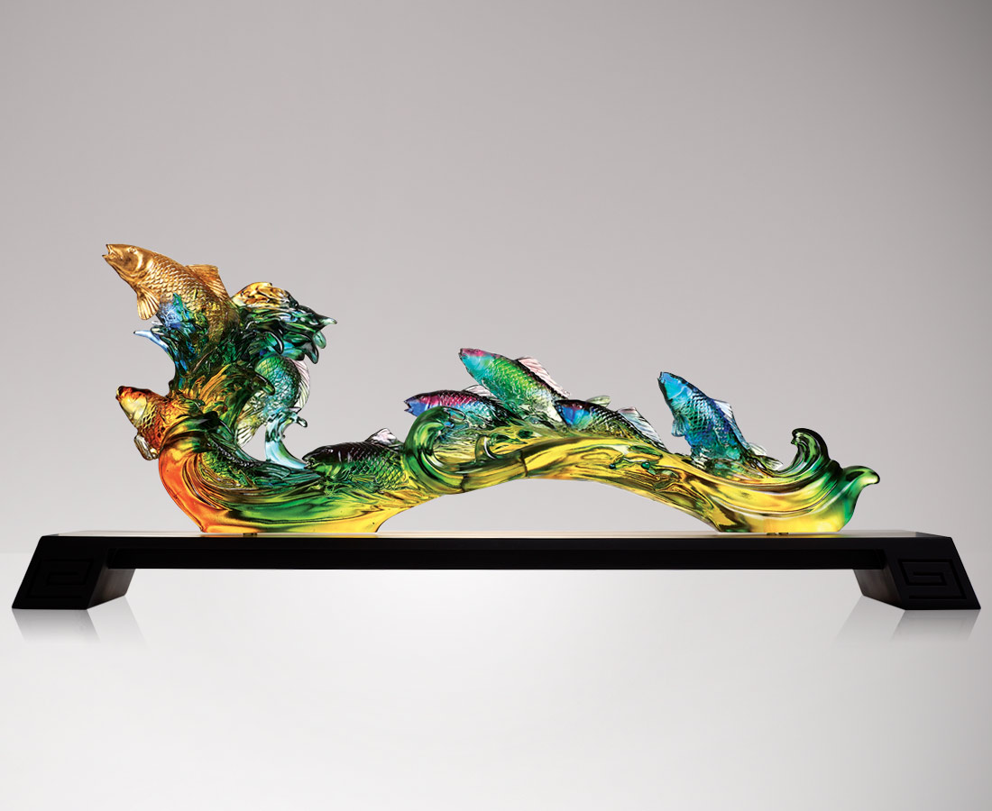
一心一意達共識
二人決心利斷金
三人謀略勝諸葛
四海兄弟共團結
五穀豐登信心足
六六大順搶時機
七分勇氣聲先至
八面威風全力赴
九久如意領風騷
A School of Carp and Ruyi
Tittot shows the carefree swimming status of fish through their superb technology. High waves roll into shape of Ruyi, blessing people with "(all things) Ru (go with) Yi (your wishes)" and "for good and all"

編號 | 1543629 | No | 1543629
名稱 | 愉躍如意 | Name | A School of Carp and Ruyi
顏色 | 藍綠青紫金琥透 | Color | blue, green, cyan, purple, golden, amber
尺寸 | 72 * 18 * 26 | Size | 72 * 18 * 26
重量 | 12.0 | Weight | 12.0
限量 | O | Limited Edition | O
售價 | NT$ 219500 | Price | NT$ 219500
 | RMB$ 48700 |  | RMB$ 48700

