如意華堂 | 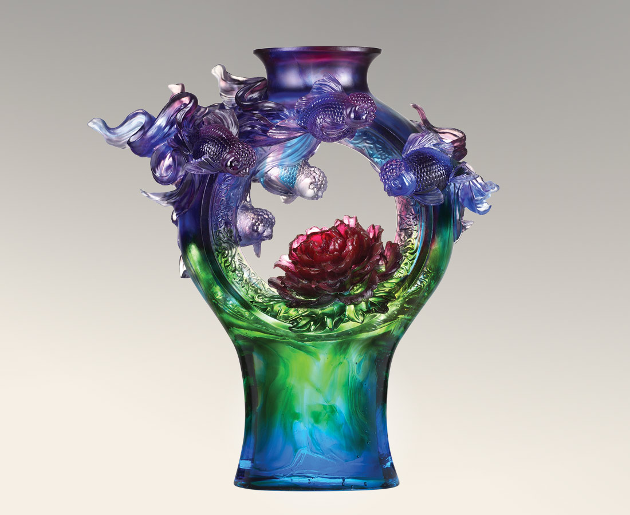
花開報春好
歌悠遊 樂悠遊
如魚得水 花好月圓
華堂煥彩 如意團團
Peony and Goldfish
In Chinese culture, peony and vase symbolize " safety and wealth of the whole family." Tittot, moreover, adds the goldfish symbolizing wealth; with its gorgeous shape and color, the house is full of sense of wonderfulness and richness.

編號 | 1543628 | No | 1543628
名稱 | 如意華堂 | Name | Peony and Goldfish
顏色 | 藍紫青紅綠透 | Color | blue ,purple ,cyan ,red ,green ,clear
尺寸 | 40 * 19 * 43 | Size | 40 * 19 * 43
重量 | 18.3 | Weight | 18.3
限量 | O | Limited Edition | O
售價 | NT$ 123900 | Price | NT$ 123900
 | RMB$ 27500 |  | RMB$ 27500

