湧躍 | 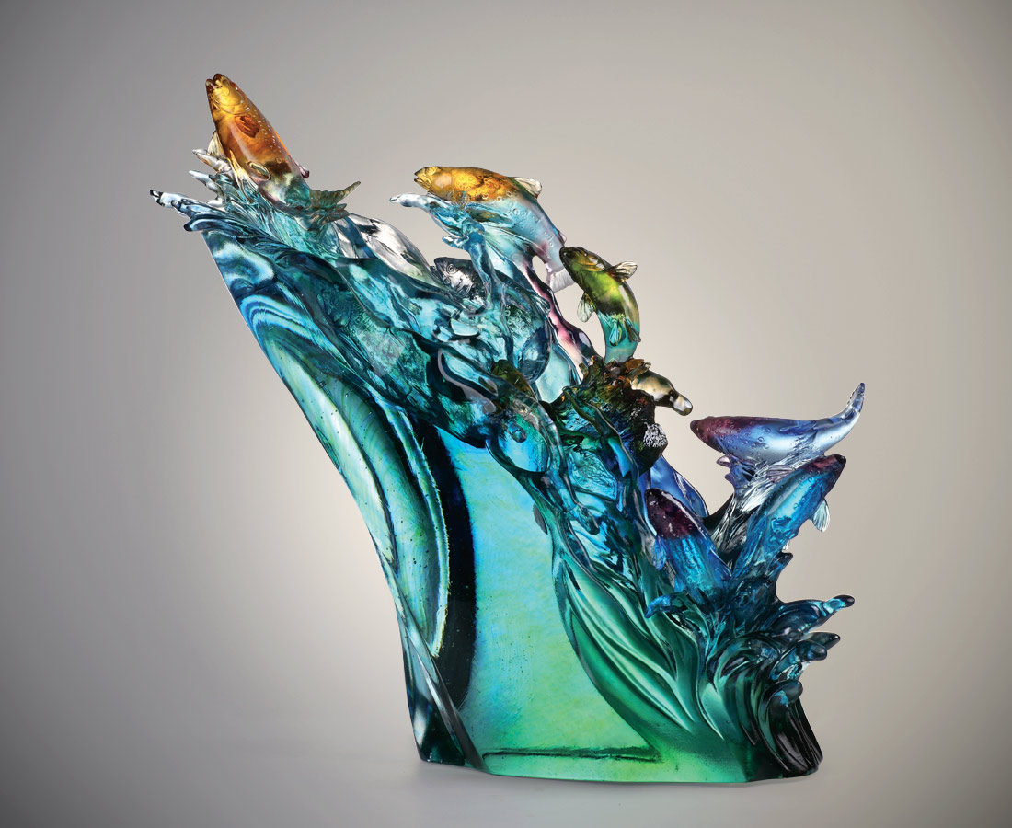
江河湖海
我自在風頭浪尖
潮往潮來
我不改英雄本色
Upstream Salmon
Tittot catches the state that salmons go countercurrent to their birthplace, and conveys spirit of not being afraid of challenges and having courage to break through the difficulties.

編號 | 1543620 | No | 1543620
名稱 | 湧躍 | Name | Upstream Salmon
顏色 | 紫琥藍綠青透 | Color | purple ,amber ,blue ,green ,cyan ,clear
尺寸 | 45 * 17 * 42 | Size | 45 * 17 * 42
重量 | 25.7 | Weight | 25.7
限量 | O | Limited Edition | O
售價 | NT$ 128000 | Price | NT$ 128000
 | RMB$ 28450 |  | RMB$ 28450

