躍舞 | 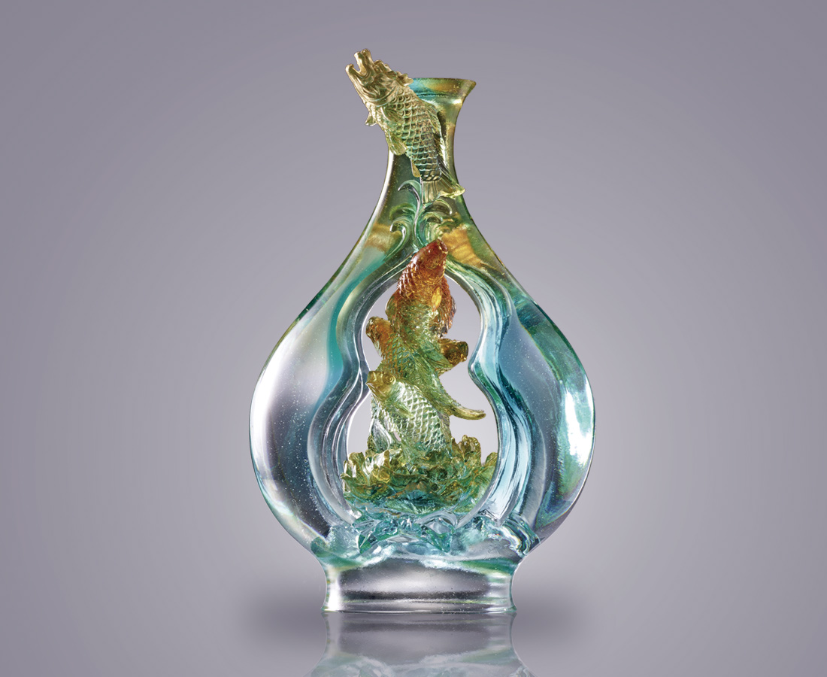
不只悠遊
更要愉躍而起
翻騰出無所不在的綻放
A School of Carp and Gourd Vase
Tittot take the Chinese phrase " Carps Jumping over the Dragon Gate " as the theme. The fish go through the hollow vase, symbolizing one becomes a true hero after challenge.

編號 | 1543612 | No | 1543612
名稱 | 躍舞 | Name | A School of Carp and Gourd Vase
顏色 | 青綠金琥藍紫透+金箔 | Color | cyan ,green ,golden ,amber ,blue ,purple
尺寸 | 16.2 * 9.2 * 25.2 | Size | 16.2 * 9.2 * 25.2
重量 | 2.4 | Weight | 2.4
限量 | X | Limited Edition | X
售價 | NT$ 20800 | Price | NT$ 20800
 | RMB$ 4500 |  | RMB$ 4500

