愉樂 | 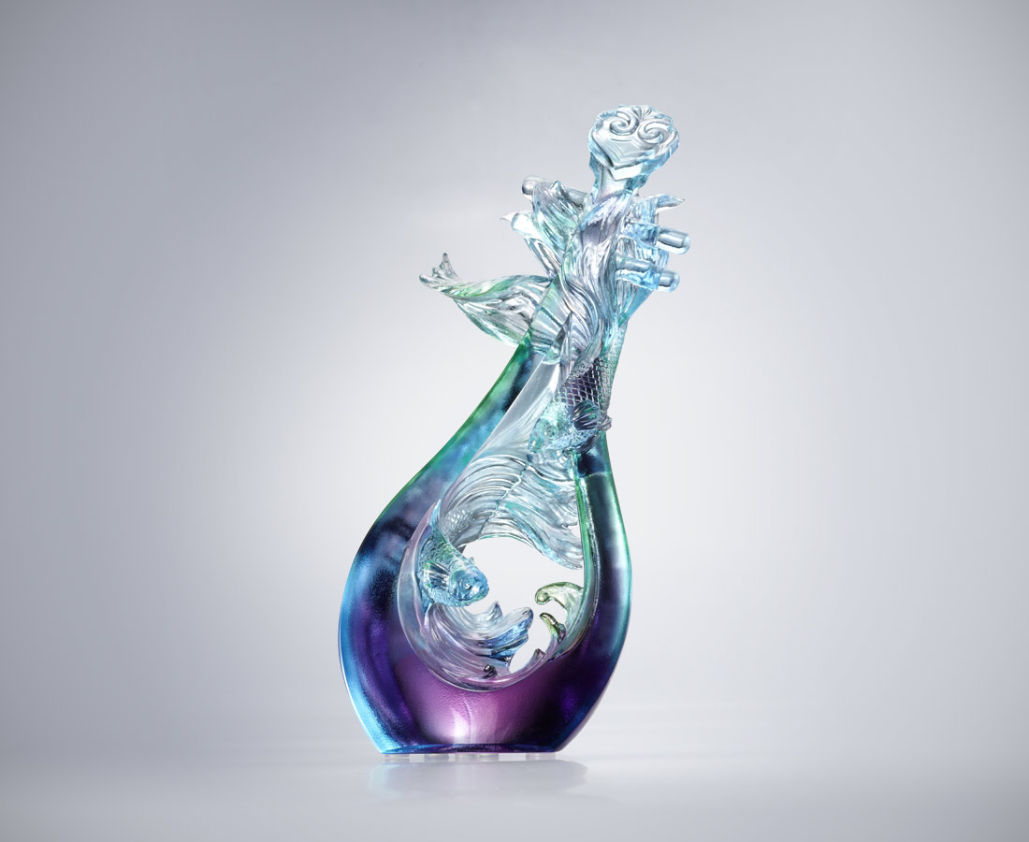
高山流水 相惜相知
處處感人和諧
音符宛轉 且歌且舞
時時快意愉悅
Guppies and Lute
Two guppies sway with the pipa’s melody. The guppies’ high and low position not only is like their dancing to each other, but also a symbol of consistency between couples or friends.

編號 | 1543599 | No | 1543599
名稱 | 愉樂 | Name | Guppies and Lute
顏色 | 藍青紫透 | Color | blue , purple , cyan , clear
尺寸 | 8 * 5 * 17 | Size | 8 * 5 * 17
重量 | 0.4 | Weight | 0.4
限量 | X | Limited Edition | X
售價 | NT$ 6880 | Price | NT$ 6880
 | RMB$ 1530 |  | RMB$ 1530

