福祿全湧 | 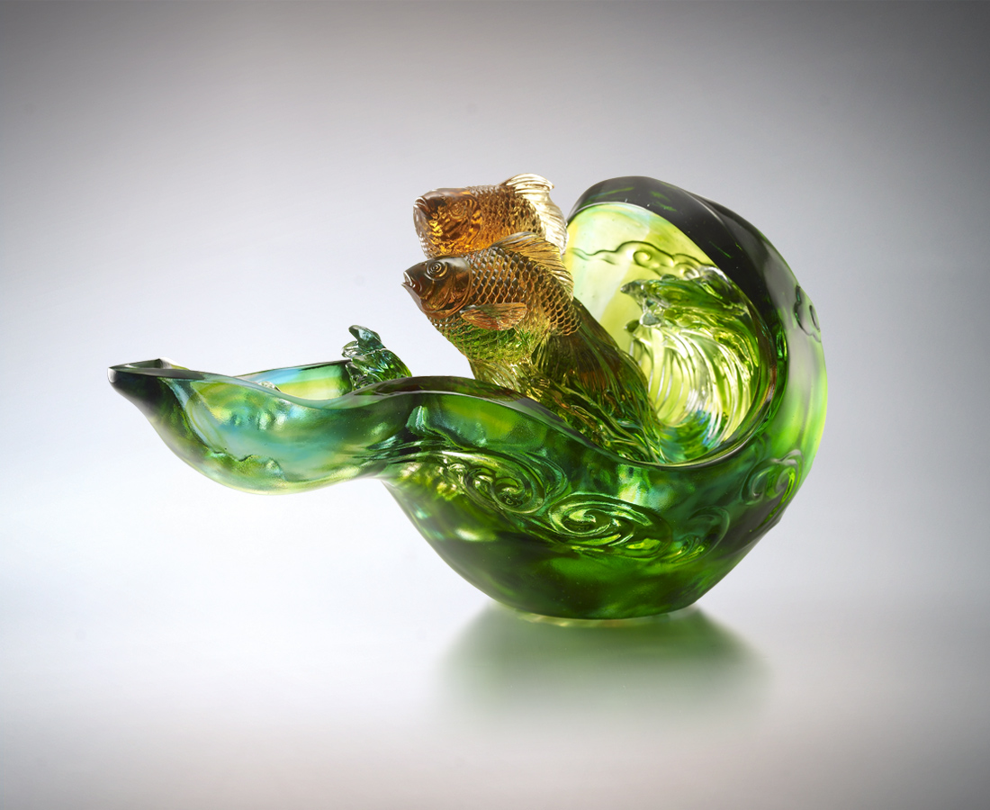
推波的節奏沖刷勇氣
乘福風 豪情衝天高
逐祿水 氣壯比海闊
把目標凌空一躍
高站浪頭
Surge of Happiness and Prosperity
Rhythmic waves of courage Driving forward happiness and prosperity Lofty sentiments as high as the sky Grandeur ambitions as wide as the ocean With the target in sight Full speed ahead

編號 | 1542922 | No | 1542922
名稱 | 福祿全湧 | Name | Surge of Happiness and Prosperity
顏色 | 青綠琥透 | Color
尺寸 | 19 * 33.2 * 19.1 | Size | 19 * 33.2 * 19.1
重量 | 7.5 | Weight | 7.5
限量 | O | Limited Edition | O
售價 | NT$ 49800 | Price | NT$ 49800
 | RMB$ 11000 |  | RMB$ 11000

