緣舞曲 | 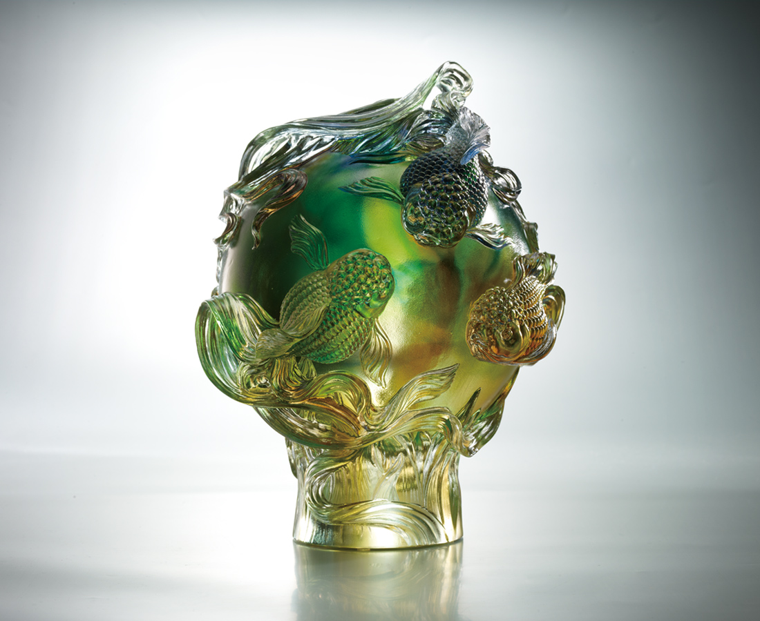
心如水鏡天自寬
能游世界好風情
能結四海金玉盟
隨水流轉 隨緣歡喜
為每次相遇結綵慶賀
All Round Prosperity
With a heart as clear as the mirror The sky is infinitely broadened When one becomes one with the world Everlasting friendships and alliances are forged Drift with the flow in pursuit of happiness Celebrating the delightfulness of each encounter

編號 | 1542917 | No | 1542917
名稱 | 緣舞曲 | Name | All Round Prosperity
顏色 | 琥綠紫藍透 | Color
尺寸 | 21.2 * 21 * 26.5 | Size | 21.2 * 21 * 26.5
重量 | 10.0 | Weight | 10.0
限量 | O | Limited Edition | O
售價 | NT$ 42800 | Price | NT$ 42800
 | RMB$ 9500 |  | RMB$ 9500

