情意圓 | 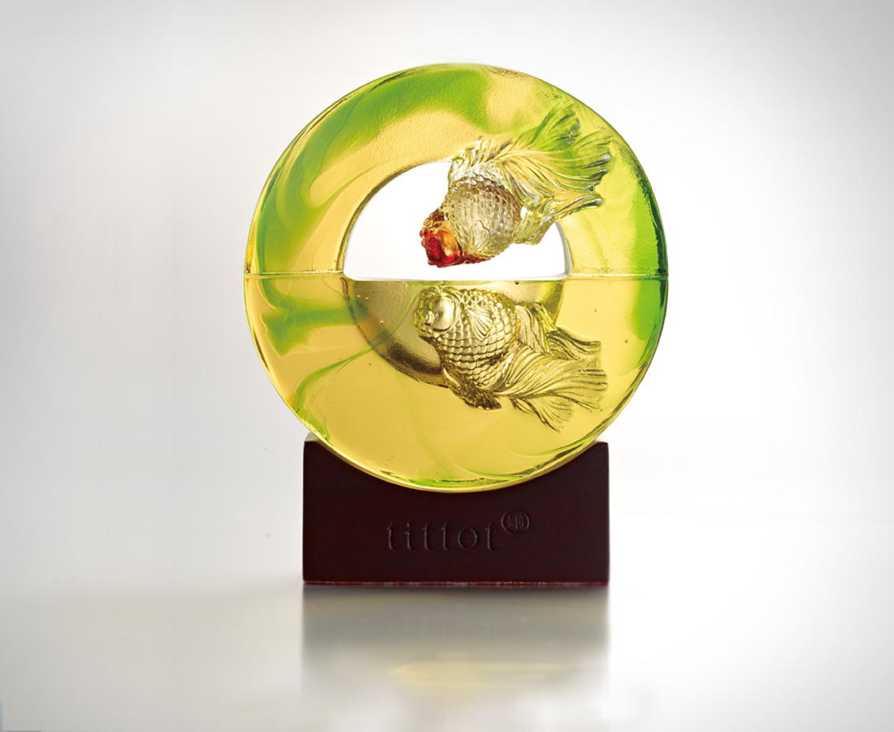
相望
照得人光彩
映得心愉悅
上下通透 內外交流
滿心滿意金玉都生輝
Loop of Affection
Gazing at each other Glowing with radiance Reflection of happiness With harmony all around As well as free flowing energy One shall be bequeathed Fortune and prosperity

編號 | 1542885 | No | 1542885
名稱 | 情意圓 | Name | Loop of Affection
顏色 | 金綠紅琥 | Color
尺寸 | 9.5 * 9.5 * 4.4 | Size | 9.5 * 9.5 * 4.4
重量 | 0.6 | Weight | 0.6
限量 | X | Limited Edition | X
售價 | NT$ 4880 | Price | NT$ 4880
 | RMB$ 1080 |  | RMB$ 1080

