情韻悠揚 | 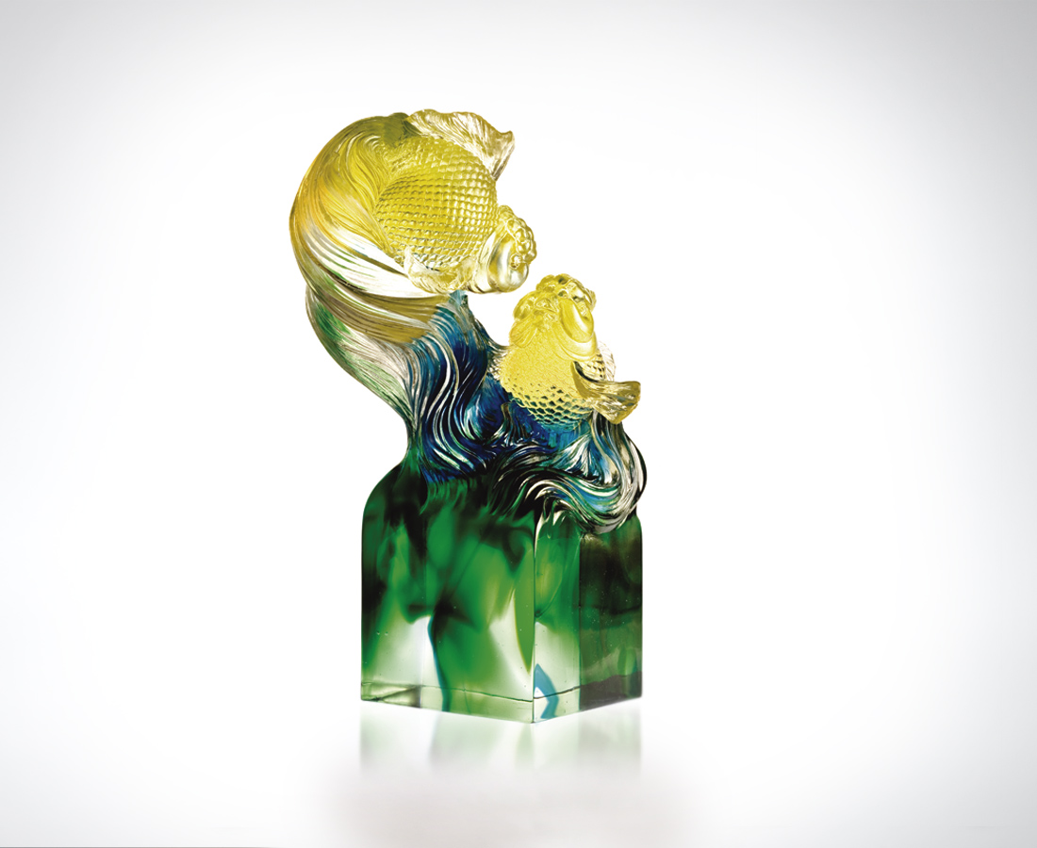
擺盪如詩的風雅對仗
悠游如歌的優哉旋律
桃花流水 詠歎對位
琴瑟和鳴 怡然對話
愛的姿態 如詩如歌
愛的美麗 就是承諾
Commitment
Elegance sways like poetry; Leisure flows like melody. The petal exchanges whispers with the stream along which she drifts The bow shares dialogues with the string against which he glides. Such lyrical poetry is the posture of love, Such beauty is the commitment of love.

編號 | 1542271 | No | 1542271
名稱 | 情韻悠揚 | Name | Commitment
顏色 | 金青綠透 | Color
尺寸 | 13.3 * 15.8 * 24.3 | Size | 13.3 * 15.8 * 24.3
重量 | 4.5 | Weight | 4.5
限量 | O | Limited Edition | O
售價 | NT$ 40880 | Price | NT$ 40880
 | RMB$ 8466 |  | RMB$ 8466

