長相左右 | 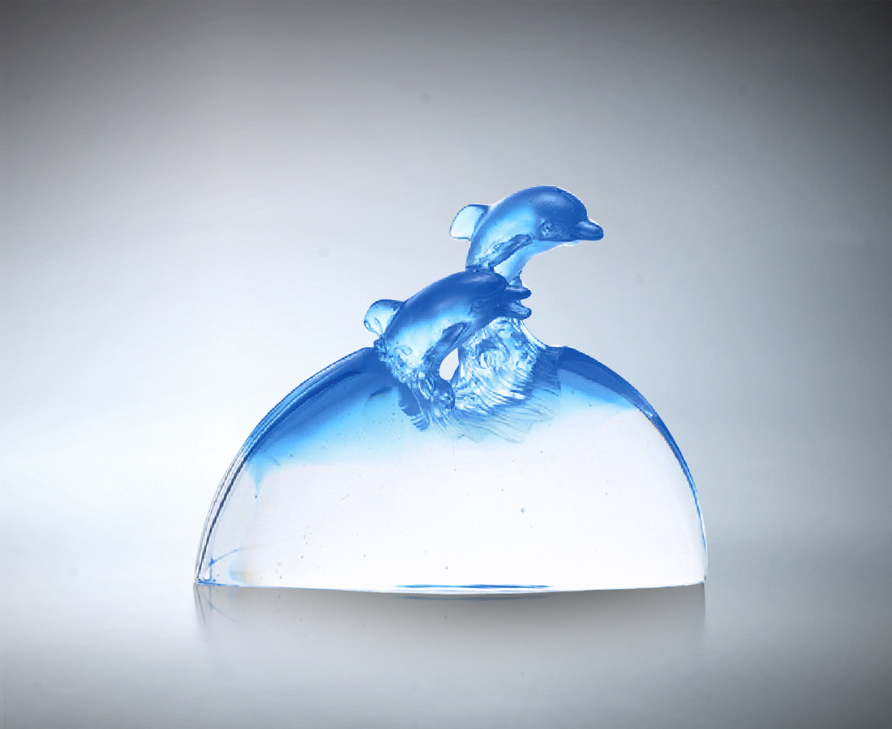
藍
坦開無邊無際的自在
在清澈淡泊裡是信心
在開闊爽朗中是信賴
我們是晴空碧海的希望
彼此扶持鼓舞地向前進
自足相伴的福份和志趣
而知長相左右的顏色
散發相知相惜的剔透光彩
Everlasting Company
Blue stands for extensive and infinite ease, With confidence embodied in limpidity and simplicity, And trust revealed in broadmindedness and straightforwardness; We are the hope of the clear sky and blue sea, Advancing forward through mutual help and encouragement, Leading to happiness and interest between us; The color of everlasting company, Emits the transparent light of mutual intimacy

編號 | 1540216 | No | 1540216
名稱 | 長相左右 | Name | Everlasting Company
顏色 | 藍透 | Color
尺寸 | 7.1 * 17.7 * 13.2 | Size | 7.1 * 17.7 * 13.2
重量 | 2.0 | Weight | 2.0
限量 | X | Limited Edition | X
售價 | NT$ 12600 | Price | NT$ 12600
 | RMB$ 3088 |  | RMB$ 3088

