一片盛情 | 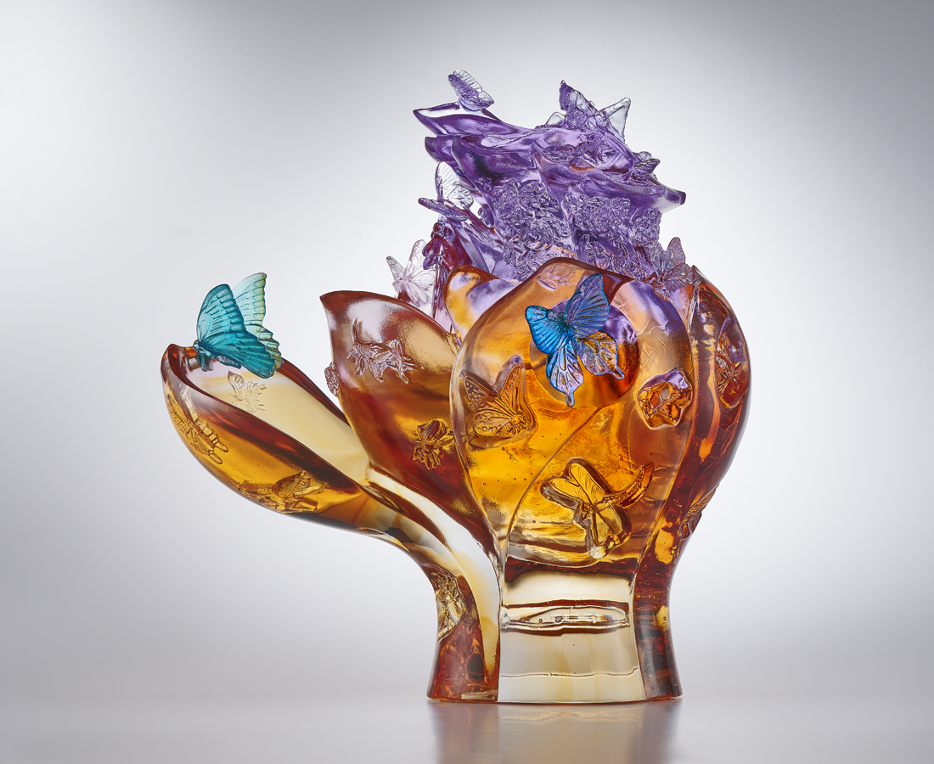
見芙蕖揮袖邀彩蝶
聞蟲語微風湧幽煙
花開時節 添生意
琴韻畫境 作諧篇
承甘露 得惠風
皆方寸之間
Invitation from the Lotus Blossom
The design of this item is inspired by the National Palace Museum’s collection “Painted Enamel Lidded Jar in the shape of a Lotus Blossom with Butterfly-and-Insect Decoration”. Which not only exhibits a unique lotus blossom silhouette but also features enamels depicting up to eight species of small, rustic creatures, in a vivacious style. tittot's designer has reinterpreted this work with a contemporary glaze art aesthetic, so that the blossom petals are like hands reaching out for invitation, adding a dynamic and playful vitality. (Includes two magnetic glazed butterflies for collectors to decorate according to their preferences.)

編號 | 1534099 | No | 1534099
名稱 | 一片盛情 | Name | Invitation from the Lotus Blossom
顏色 | 紫羅蘭青紫琥粉紅透 | Color | violet, cyan, purple, amber, pink, clear
尺寸 | 26.5 * 20 * 26.9 | Size | 26.5 * 20 * 26.9
重量 | 8.3 | Weight | 8.3
限量 | O | Limited Edition | O
售價 | NT$ 64800 | Price | NT$ 64800
 | RMB$ 14400 |  | RMB$ 14400

