如虎添翼 | 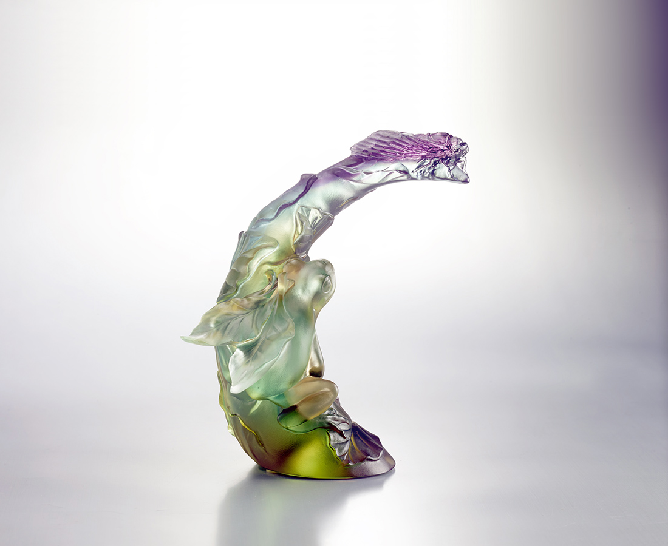
想飛
就揹起夢想
有夢
才是真正的如虎添翼想飛
就揹起夢想
有夢
才是真正的如虎添翼
With Strength Redoubled
A frog puts on leaves like a cloak, as if it had the power to fly. The designer thereby conveys the idea that dreams are what grant us the power to move forward.

編號 | 1533782 | No | 1533782
名稱 | 如虎添翼 | Name | With Strength Redoubled
顏色 | 金青紫透 | Color | golden, cyan, purple, clear
尺寸 | 12.4 * 10.1 * 14.4 | Size | 12.4 * 10.1 * 14.4
重量 | 0.67 | Weight | 0.67
限量 | X | Limited Edition | X
售價 | NT$ 6380 | Price | NT$ 6380
 | RMB$ 1420 |  | RMB$ 1420

